

**UNIVERSITÀ DEGLI STUDI DI MESSINA**

**DIPARTMENT:**

Scienze matematiche e informatiche, scienze fisiche e scienze della terra

**DEGREE COURSE:**

INFORMATICA

Software Development Project Report



Movie Recommendation System By Bot

By: Tien M. Nguyen

Guided by: Professor Distefano Salvatore

Academic year 2017-2018

Contents

I. Overview 6

1. Introduction 6

II. Software process 6

1. Chosen process: Scrum 6

2. Why Scrum? 6

3. Three phases in Scrum 7

4. Three main roles in Scrum 7

5. Sprint cycle 7

III. Initial phase 8

1. Project members 8

2. Project ideal 8

3. Technologies used 8

4. Requirements Analysis 9

4.1. Functional requirements 10

4.2. Non-functional requirements 11

4.3. Use case diagram 11

5. Backlog refinement 12

6. Project estimation 12

IV. Sprint cycles 13

1. Sprint 1 13

1.1. Planning 13

1.2. Implementation 13

1.3. Review 14

1.4. Retrospective 14

2. Sprint 2 15

2.1. Planning 15

2.2. Implementation 15

2.3. Review 16

2.4. Retrospective 16

3. Sprint 3 17

3.1. Planning 17

3.2. Implementation 17

3.3. Review 18

3.4. Retrospective 18

4. Sprint 4 19

4.1. Planning 19

4.2. Implementation 19

4.3. Review 19

4.4. Retrospective 20

V. Project termination 20

1. Reason why project was terminated 20

2. Product Owner mistakes 20

3. Scrum Master mistakes 20

4. Development Team mistakes 20

VI. Initial phase (2nd) 20

1. Project members 20

2. Project Ideal 21

3. User Story 21

4. Reuse from terminated Scrum 21

5. Technologies used 21

6. Requirements Analysis 22

6.1. User requirements 22

6.2. Use case diagram 23

6.3. Functional requirements 23

6.4. Non-functional requirements 25

6.5. Domain requirements 25

6.6. Data Preparation 25

7. Architectural Design 26

7.1. Components Diagram 26

7.2. Database Design 27

7.3. Backend Design 28

7.4. Frontend Design 30

7.5. Sequence Diagram 32

8. Backlog refinement 34

8.1. Epic 34

8.2. Feature 34

8.3. Product Backlog 35

8.4. Priority assignment 37

9. Project estimation (time and cost) 38

VII. Sprint cycles (2nd) 39

1. Sprint 1 39

1.1. Planning 39

1.2. Implementation 39

1.3. Review 39

1.4. Retrospective 40

2. Sprint 2 41

2.1. Planning 41

2.2. Implementation 42

2.3. Review 42

2.4. Retrospective 44

3. Sprint 3 44

3.1. Planning 44

3.2. Implementation 45

3.3. Review 45

3.4. Retrospective 47

4. Sprint 4 47

4.1. Planning 47

4.2. Implementation 49

4.3. Review 50

4.4. Retrospective 51

VIII. Project closure 52

1. Release Burn Up Chart 52

2. Verification test 52

3. Validation test 55

4. Operation plan and Deployment order 56

4. Database Deployment 56

5. Backend Deployment 60

6. Frontend Deployment 66

7. Scale solutions 75

IX. Recommendation System Algorithm Design 76

1. Foundation 76

2. Loss Function 77

3. Optimizing the loss function 77

4. Development in Python 79

5. Model input explanation 81

6. Model explanation 84

7. Functions that affect the model 84

8. Model application 85

X. Production Screenshots 87

# Overview

## Introduction

This is a project report for Software Engineering at the University of Messina taught by Professor Distefano Salvatore. The purpose of the project is to apply a process to create a complete system software product.

The idea of the system can be chosen freely with the consent of the professor and will be presented below.

The product development process I use is Scrum, one of the most popular frameworks for Agile implementation. I work on this project alone and I will play all three main roles in a Scrum project. Taking on all three roles in Scrum is not recommended because Scrum in particular and software development processes in general were born to solve problems related to independent interpersonal cooperation.

## Project Idea

The idea of the project came from the idea of researching and building recommendation systems. From there, we create a system that can be applied the recommendation system.

# Software process

## Chosen process: Scrum

Scrum is one of the most popular frameworks for Agile implementation. Scrum focuses on managing iterative development rather than specific Agile practices.

## Why Scrum?

As I say in the first section, Scrum is an Agile framework that is particularly suited for complex projects with rapidly changing requirements, which is often the case in software development. In this project, requirements change based on recommendation systems research is very likely to happen, so Scrum or Agile in general is a reasonable choice for this project. Additionally, Scrum allows for frequent iterations and feedback loops, which can help ensure that the final product meets the needs of stakeholders.

Mention of stakeholders, because this project only has the participation of one person, traditional Agile will not be suitable because all the members in the team will share all roles, all responsibilities. With Scrum, there is a clear division of roles in the three positions of Product Owner, Scrum Master and Development Team which makes it easier to simulate a team using this methodology. I can still understand the difficulty of each position in the project through the work that role needs to do.

Furthermore, Scrum can help ensure that the project remains on track and that potential issues are identified and addressed early on in the development process. Scrum’s emphasis on frequent communication and collaboration can help ensure that all members of the team are aware of any potential issues and are working together to address them.

Overall, choosing Scrum can help ensure that the final product meets the needs of stakeholders, is delivered on time, and is of high quality.

## Three phases in Scrum

There are three phases in Scrum:

* Initial phase: in this phase we establish the general objective for the project and design the software architecture. This phase includes the processes related to initiation of a project: Create Project Vision, Identify Stakeholder(s), Scrum Master and Product Owner, Form Scrum Team, Create Prioritized Product Backlog, and Conduct Release Planning.
* Sprint cycle phase: this is a series of sprint cycles, where each cycle develops an increment of the system. This phase includes the processes related to implementation of a project: Create Deliverables, Conduct Daily Standup, Groom Prioritized Product Backlog, and Deliver Deliverables.
* Project closure phase: wraps up the project, completes required documentation such as system help frames and user manuals and assesses the lessons learned from the project. This phase includes the processes related to releasing a project: Ship Deliverables and Retrospect Project.

## Three main roles in Scrum

There are three main roles in Scrum:

* Product Owner: The Product Owner is responsible for maximizing the value of the product resulting from the work of the Development Team. They are also responsible for managing the Product Backlog. They do analysis, are business-oriented, do external interactions-interface. They will keep the team Build the right thing.
* Scrum Master: The scrum master is responsible for ensuring that Scrum is understood and enacted by all team members and stakeholders. They are servant leader, advisor, coach, mentor, facilitator. They will keep the team Build it fast.
* Development Team: The development team is responsible for delivering a potentially releasable increment of “Done” product at the end of each Sprint. They are self-management or self-organizing. They will keep the team Build things right.

## Sprint cycle

Sprint are fixed length, normally 2-4 weeks. In this project one sprint is 5 working days.

Usually, each sprint will have 4 phases:

* Planning: before each sprint, the team selects what it will commit to delivering by the end of the sprint, starting at the top of the product Backlog. During the sprint, what the team committed to deliver does not change, and the end-date of the sprint does not change. If something major comes up, the Product Owner can direct the team to terminate the Sprint prematurely and start a new one.
* Implementation – Daily Scrum Meeting: each day, the team has a short meeting to update each other on progress and surface blocks. They stand up, to keep it fast. To keep the meeting to less than 15 minutes, everyone reports just 3 things: done since yesterday, done by tomorrow, and blocks. Burndown Chart are necessary for the team to successfully self-manage.
* Review: at the end of the sprint, the Product Owner, Team, Scrum Master, and Stakeholder(s) come together and see a demo of what the team has produced. The Product Owner gathers feedback from everyone on ways to improve what has been built. Review of the timeline, budget, potential capabilities, and marketplace for the next anticipated releases of functionality and capabilities.
* Retrospective: Team, Product Owner, and Scrum Master meet at the end of each Sprint to review their way of working, to improve effectiveness. Usually, it will take 3 hours for one month Sprint. This is the opportunity for the Scrum Team to improve and all members should be in attendance, discussing about: what went well, what could be improved, and what we will commit to improving in the next Sprint.

# Initial phase

## Project members

* Product Owner: Nguyen Minh Tien
* SCRUM Master: Nguyen Minh Tien
* Member in Team: Nguyen Minh Tien

Taking on all three roles in SCRUM is not recommended because SCRUM in particular and software development processes in general were born to solve problems related to independent interpersonal cooperation. I must do this project alone because I could not find the right partner at the right time. However, I will try to play each role independently so that I can understand in a project what the roles will contribute.

## Project ideal

The Ideal of Project is a website where users can get suggested which movies they might like. They will also be able to rate on a 5-point scale the movies they have watched. The system will use a machine learning algorithm to determine which movies users will like based on data given. The more movies they rated, the more accurate the suggested movies would be.

No User Story given.

## Technologies used

* Git for Source control

Git is a popular version control system for tracking changes in software code, supporting collaboration, branching, and merging. It is widely used in software development to manage and organize code changes efficiently.

* Draw.io for Designing

Draw.io is a free, online diagramming tool for making flowcharts, UML diagrams, network diagrams, and more. It offers a simple interface, pre-made templates and shapes, collaboration, and integration with other tools. All diagrams in this project are drawn with Draw.io.

* Postman for Testing

Postman has a GUI and can send and view HTTP requests and responses.

* Azure DevOps for Scrum management

Azure DevOps is a suite of development tools, services, and features offered by Microsoft for software development teams to plan, develop, test, and deliver software. It includes services for Agile project management, continuous integration and delivery, testing, and more.

* PostgreSQL for Database Management

PostgreSQL is an open-source object-relational database system that uses and extends the SQL language.

* Django for Backend

Django is a high-level Python web framework used for developing dynamic and scalable web applications. It provides a clean and efficient way to build and maintain applications, with features such as URL routing, template engine, object-relational mapping, and security features.

* ReactJS for Frontend

React is a JavaScript library for building user interfaces, commonly used for developing single-page applications and mobile applications. It uses a component-based approach, allowing developers to build complex UIs by composing simple and reusable components. React also uses a virtual DOM for efficient updates and rendering, making it fast and efficient for dynamic applications.

## Requirements Analysis

In the initial iteration, I prioritized rapid development of the ideal solution and analyzed the data to identify the suitable machine learning models for the data.

The software will allow the user to perform the various functions:

* Create Account
* Login
* Search for movie
* Get suggested movie
* See a list of movies
* See a specific movie
* Rate a movie
* Logout

The “Create Account” operation allows a new user or guess who has just had access to the software to be able to register and access the software functions. Registration is required since we need user rating movie data.

The “Login” operation allows a user who already has access to the application to be able to reconnect to the system by entering the same data that he entered during the previous registration period.

The “Search for Movie” operation will allow a logged in user to find the exact movie they want to rate.

The “Get Suggested Movie” operation will allow a logged in user to get their might-like movies by the machine learning algorithm.

The “See a list of movies” operation will allow a logged in user to get a list after the operations “Search for Movie” or “Get Suggested Movie”.

The “Rate a Movie” operation will follow the “Search for Movie” which will allow user to rate a movie and save the rate in the database, maybe a function “Remove a Rate” will appear in the future.

The “Get Suggested Movie” operation is the main operation which will allow a user to get their suggested movies that they might like to depend on the machine learning model we develop.

Finally, the “Logout” operation will allow a logged in user to logout from system. Users will need to login again if they need to do any other action on the next connection.

### Functional requirements

Functional requirements refer to the product features or functions that must be implemented by the development team to enable users to carry out their tasks. It is important to make these requirements clear for both the development team and stakeholders. Typically, functional requirements describe the system's behavior in specific circumstances. Below are functional requirements for software:

FR.1: Authenticate Management:

* FR.1.1: Registration User
* FR.1.2: Verify User

FR.2: Movie Management:

* FR.2.1: Movie Searching
* FR.2.2: Movie Suggestion

FR.3: Rating Management:

* FR.3.1: Create Rating

### Non-functional requirements

Nonfunctional requirements, not related to the system functionality, rather define how the system should perform. Below are non-functional requirements for software:

NFR.1: Friendly Graphic User Interface.

NFR.2: Multiplatform compatible.

NFR.3: Fast response to user.

NFR.4: Movie cover should be available.

### Use case diagram

The specifications for the first software prototype involve a thorough analysis of the customer requirements, which is important and requires careful attention as it determines whether the customer’s needs goods are met or not. A “use case diagram” will be used to describe the relationship clearly and accurately between users and the actions they can take while using the software.

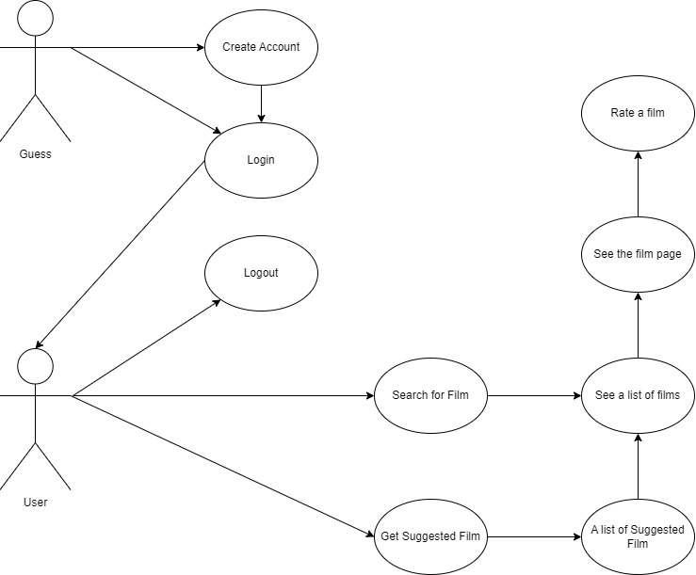

## Backlog refinement

From the Requirements Analysis, as a Product Owner, I have refined the backlog as follows (priority order is from top to bottom).

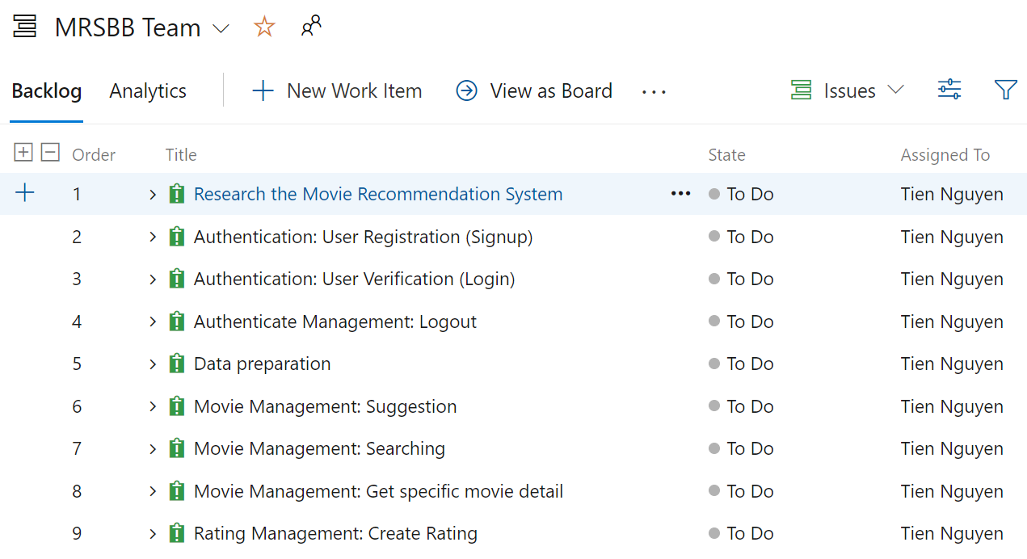

## Project estimation

There will be three approaches to building a Recommendation System so the First Issue will take 3 Sprints to complete.

At the same time, we can complete the authentication system in 2 Sprints and Data preparation in 1 Sprint.

There will be one last Sprint for combining components into a complete system.

All the designs will be done in Sprint where the feature or system is in “Doing” status.

Testing will take place right when a feature is in “Done” status as unit tests. The final test phase will take place when all the system is done as a system test.

So, there will be 4 Sprints:

1. Sprint 1 runs from 2nd Jan to 6th Jan (5 working days). Issues: 1,2.
2. Sprint 2 runs from 9th Jan to 13th Jan (5 working days). Issues: 1,3,4.
3. Sprint 3 runs from 16th Jan to 20th Jan (5 working days). Issues: 1,5.
4. Sprint 4 runs from 23rd Jan to 27th Jan (5 working days). Issues: 6,7,8,9.

# Sprint cycles

## Sprint 1

### Planning

As we discussed in section III.5 Project estimation, in this Sprint, Issues 1 and 2 will be taken care of. All the tasks for these two issues are as below:

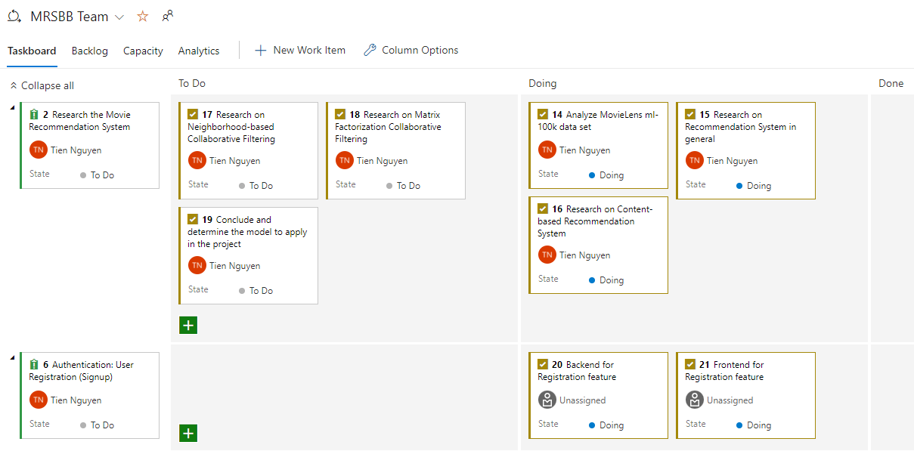

### Implementation

The result of Analyze MovieLens ml-100k data set appears in the document: “Recommendation_System”.

The result of Research on Recommendation System in general appears in the document: “Recommendation_System”.

The result of Research on Content-based Recommendation System appears in the document: “Recommendation_System”.

For Backend for Registration feature, I use Django for rapid development since its authentication system can be developed with a few configurations.

For Frontend for Registration feature, I use ReactJS, a popular JavaScript library for building user interfaces.

### Review

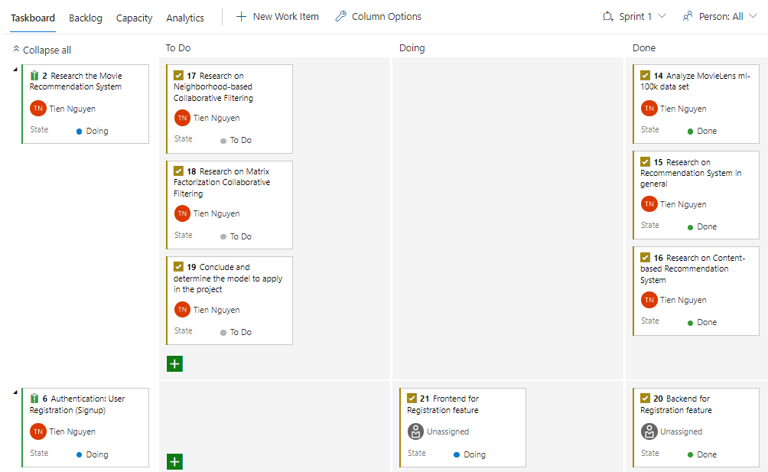

After the first Sprint, most of the tasks set out have been completed. However, because I spent too much time learning about the recommendation system, I could not complete the authentication function.

### Retrospective

Certainly, in the next Sprint the time spent on the recommendation system will be reduced because the background knowledge has been learned in this Sprint. I'll have to try to build the authentication function in the next Sprint.

## Sprint 2

### Planning

As we discussed in section III.5 Project estimation, in this Sprint, Issues 1, 3 and 4 will be taken care of. All the tasks for these two issues are as below: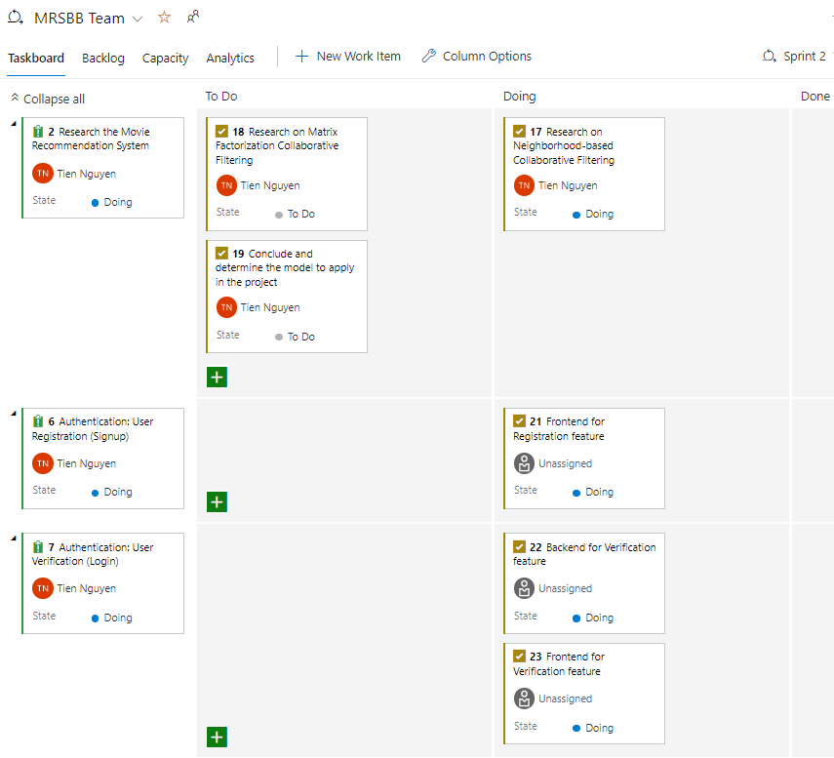

### Implementation

The result of Research on Neighborhood-based Collaborative Filtering appears in the document: “Recommendation_System”.

For Backend for Verification feature, I use Django for rapid development since its authentication system can be developed with a few configurations.

For Frontend for Verification feature and Frontend for Registration feature, I made it with ReactJS.

### Review

So, what I planned for this week is done. I have finished tuning Django as well as creating a GUI with the help of the ReactJS framework. 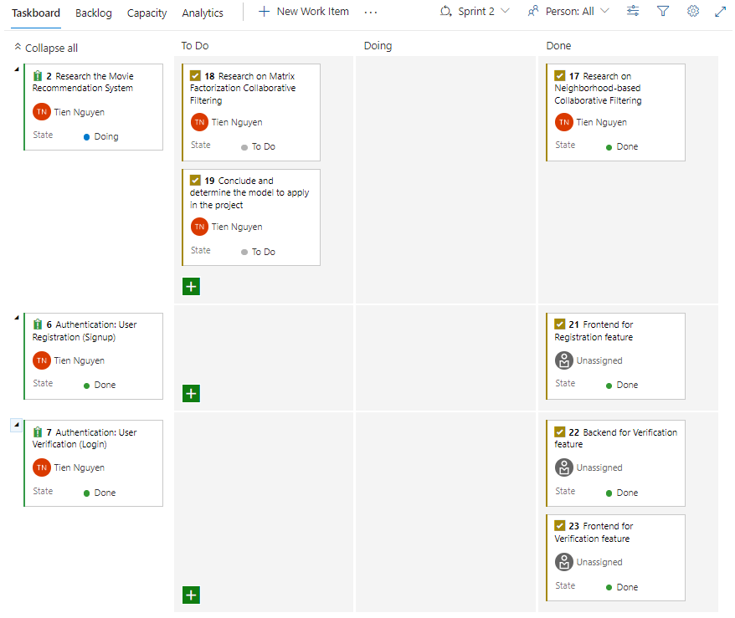

### Retrospective

In the next week, I will research another algorithm for the Recommendation System from which to conclude and choose the best option for this project.

Along with that is to apply that recommendation system model to actual data and hope to be able to complete the application soon.

## Sprint 3

### Planning

As we discussed in section III.5 Project estimation, in this Sprint, Issues 1 and 5 will be taken care of. All the tasks for these two issues are as below: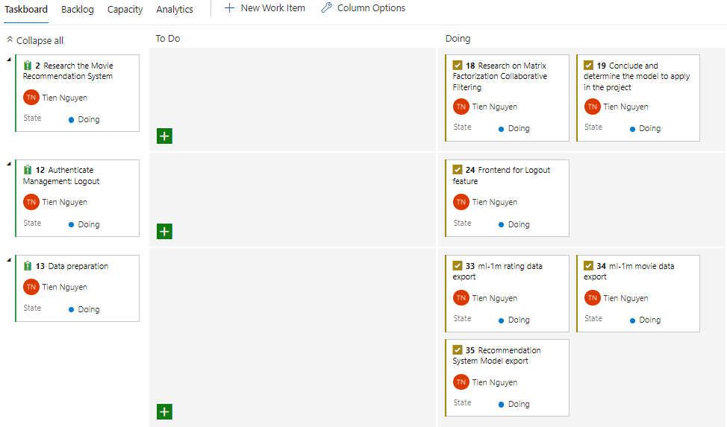

### Implementation

The result of Research on Matrix Factorization Collaborative Filtering appears in the document: “Recommendation_System”.

The result of Research on Conclude and determine the model to apply in the project appears in the document: “Recommendation_System”.

For Frontend for Logout feature, in client side I remove session so that user need to login again.

For Frontend for Verification feature and Frontend for Registration feature, done.

The result of ml-1m rating data export appears in the document: “Data_Preparation”.

The result of ml-1m movie data export appears in the document: “Data_Preparation”.

The result of Recommendation System Model export appears in the document: “Data_Preparation”.

### Review

So, what I planned for this week is done. I have finished all the tasks taken.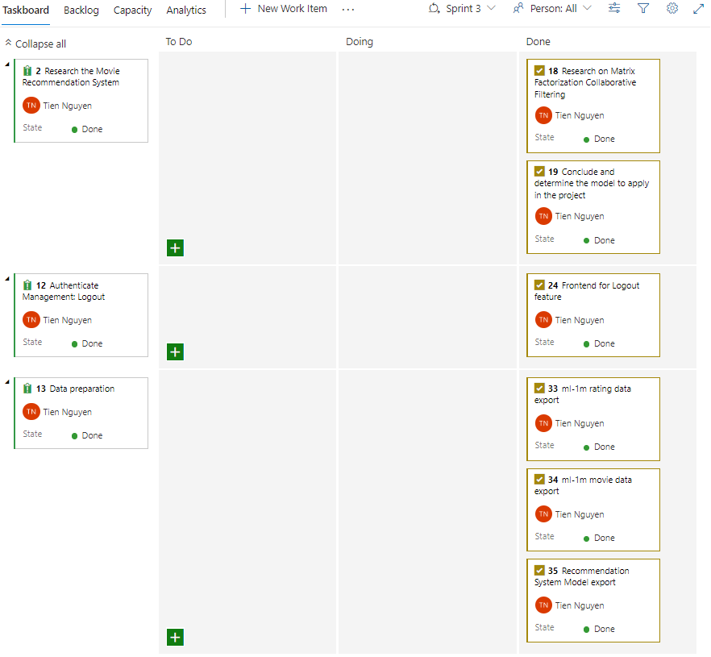

### Retrospective

Perhaps if there are more requests from customers in the future, the Backend will have to change the framework to be able to customize it more deeply as well as master the logic thereby limiting security issues even though Django is supported by the community quite well. good but maybe one day there will be a zero-day vulnerability.

## Sprint 4

### Planning

As we discussed in section III.5 Project estimation, in this Sprint, Issues 6,7,8 and 9 will be taken care of. All the tasks for these two issues are as below: 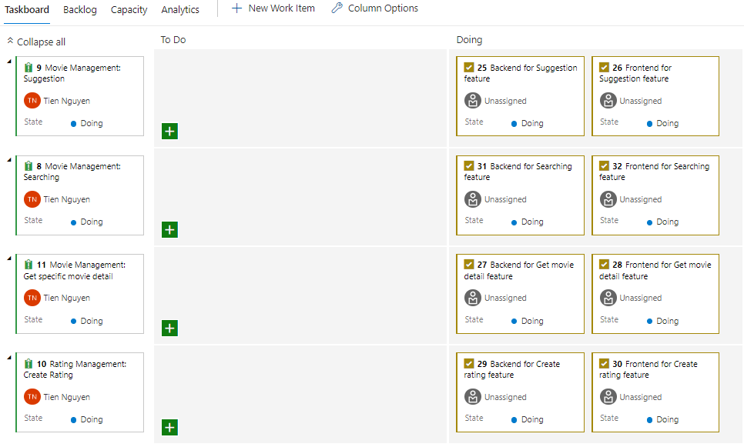

### Implementation

All the tasks done by development.

### Review

All the tasks done by development.

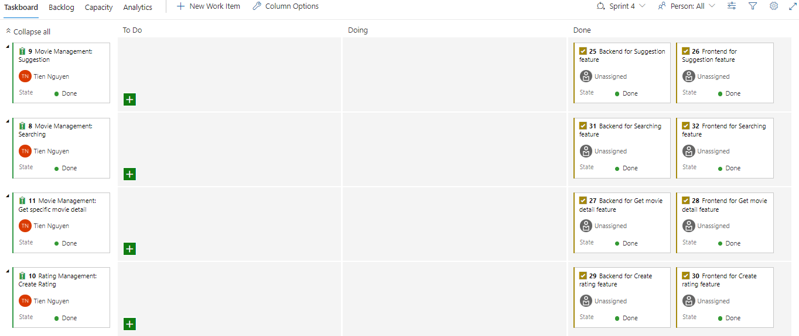

### Retrospective

Perhaps if there are more requests from customers in the future, the Backend will have to change the framework to be able to customize it more deeply as well as master the logic thereby limiting security issues even though Django is supported by the community quite well. good but maybe one day there will be a zero-day vulnerability.

# Project termination

## Reason why project was terminated

After presenting the project progress to the Stakeholders, there were some points they were not satisfied with, and the Product Owner decided to immediately stop the project and start over.

Stakeholders: Professor Distefano Salvatore, Nguyen Minh Tien.

## Product Owner mistakes

The Sprints are not properly described: the product and sprint backlog are incomplete; description is missing as well as priority assignment and task identification.

There is no role such as Admin who can manage movies and users.

## Scrum Master mistakes

In the retrospective there are no burndown charts.

Django is good for rapid development but it’s hard to deeply control the whole system.

And because of using Django, we are forced to use a RDBMS which is not good for machine learning model.

## Development Team mistakes

Final design is missing, there are no architectural diagrams such as component/deployment/class diagrams explain the architectural, its components and the overall software system organization.

There is no algorithm design, which can be represented by activity, sequence/collab or state chart diagram.

The testing phase is missing.

There is quite a long description of the recommendation system, but it should be contextualized with the requirements and associated with specific tasks identified in the sprint backlog.

# Initial phase (2nd)

## Project members

* Product Owner: Nguyen Minh Tien
* Scrum Master: Nguyen Minh Tien
* Development Team member: Nguyen Minh Tien.

Taking on all three roles in SCRUM is not recommended because SCRUM and software development processes in general were born to solve problems related to independent interpersonal cooperation.

## Project Ideal

The Ideal of Project is a website where users can get suggested which movies they might like. They will also be able to rate on a 5-point scale the movies they have watched. The system will use a machine learning algorithm to determine which movies users will like based on data given. The more movies they rated, the more accurate the suggested movies would be.

## User Story

The system should be divided into three separate components: Database, Backend, Frontend.

Backend will connect to Database through a driver library, Backend and Frontend will communicate with each other via HTML Request.

Database is optional and does not have to be noticed. The only note is to ensure the security of the data.

The Backend must be developed as can release designs in the end explaining to the Stakeholders the algorithms and mechanisms therein.

The Frontend will need the following features for users: Create Account, Login, Logout, etc. for Authentication; After login successfully, user can access to these features:

* Search Movie

There will be an input form and users can get a list of movies matched to what they type.

* Suggest Movie

Recommendation system will give users top movies they might like.

After clicking on any movie on the movies list, users will turn to a page where they can see more details about the movie, here users can create rating or update rating and delete rating.’

## Reuse from terminated Scrum

* Data extraction
* Frontend with ReactJS Library
* Movie Recommendation System Research

## Technologies used

* Git for Source control.
* Draw.io for Designing.
* Postman for Unit test.
* Azure Dev for Scrum management and CICD.
* Microsoft Azure for Deployment.
* MongoDB instead of ~~PostgreSQL~~ for Database.
* Flask Framework instead of ~~Django Framework~~ for Backend.
* ReactJS library for Frontend.

## Requirements Analysis

### User requirements

The software will allow the user to perform the various functions:

* Create Account
* Login
* Logout
* Search for movie
* Get suggested movie
* Get a specific movie detail
* Create new rating
* Read existed rating
* Update existed rating
* Delete existed rating

If the logged in user is an Admin, they will be able to perform the various functions:

* Login
* Logout
* Get a list of all users
* Get a specific user detail
* Delete a specific user
* Get a list of all movies
* Get a specific movie detail
* Delete a specific movie
* Add a new movie

### Use case diagram

From the Functional Requirements analyzed in the previous section, I have come up with a use case diagram as follows: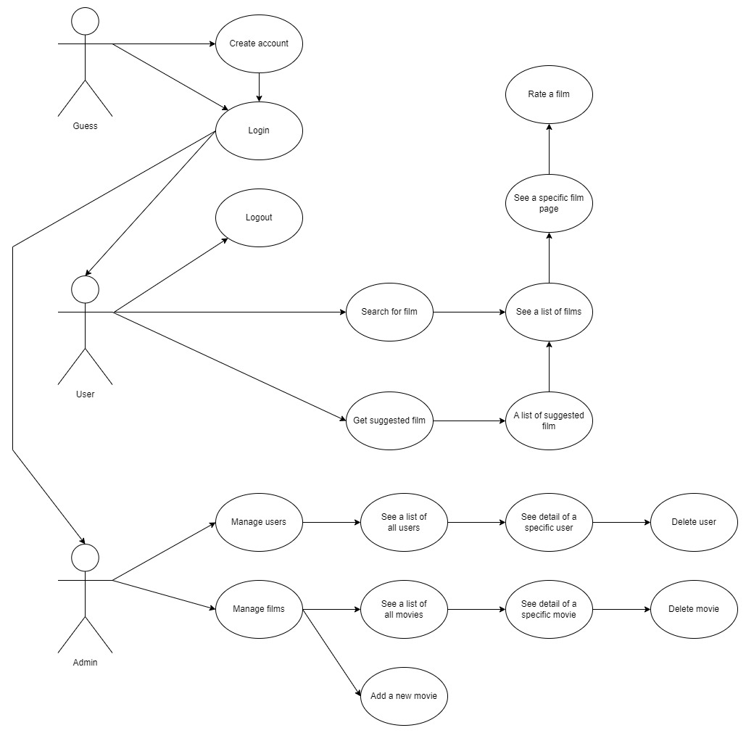

### Functional requirements

Functional requirements refer to the product features or functions that must be implemented by the development team to enable users to carry out their tasks. It is important to make these requirements clear for both the development team and stakeholders. Typically, functional requirements describe the system's behavior in specific circumstances. Below are functional requirements for software:

FR.1: User Authenticate Management:

* FR.1.1: User Registration
* FR.1.2: User Login
* FR.1.3: User Verification
* FR.1.4: User Logout
* FR.1.5: User Load

FR.2: Movie Management:

* FR.2.1: User Search Movie
* FR.2.2: User Get Movie Details

FR.3: Rating Management:

* FR.3.1: User Create Rating
* FR.3.2: User Read Rating
* FR.3.3: User Update Rating
* FR.3.4: User Delete Rating

FR.4: Recommendation System:

* FR.4.1: User Get Suggested Movies
* FR.4.2: User Get Prediction For A Movie

FR.5: Admin Authenticate Management:

* FR.5.1: Admin Login
* FR.5.2: Admin Logout
* FR.5.3: Admin Load

FR.6: Admin Users Management:

* FR.6.1: Admin Get All Users
* FR.6.2: Admin Get User Details
* FR.6.3: Admin Delete User

FR.7: Admin Movies management:

* FR.7.1: Admin Get All Movies
* FR.7.2: Admin Get Movie Details
* FR.7.3: Admin Add New Movie
* FR.7.4: Admin Delete Movie

### Non-functional requirements

Nonfunctional requirements, not related to the system functionality, rather define how the system should perform. Below are non-functional requirements for software:

NFR.1: Friendly Graphic User Interface.

NFR.2: Multiplatform compatible.

NFR.3: Fast response to user.

NFR.4: Movie cover should be available

NFR.5: User passwords should be encrypted.

### Domain requirements

Since the production will be a web application, domain requirements can include expectations related to performance, scalability and usability. In this project, the domain requirements are:

DR.1: Must have internet connection.

DR.2: Access through a Browser.

### Data Preparation

Since the data set for model training is MovieLens ml-1m: [MovieLens 1M Dataset | GroupLens](https://grouplens.org/datasets/movielens/1m/)

The data is not so clean, so I need to prepare 3 things:

* Ratings with Timestamp

Last time, when I worked with PostgreSQL database, I needed to turn epoch timestamp to date data type to match SQL data type, but I no longer need it since I now use MongoDB.

* Movies with Poster URLs

This is needed for NFR.4: Movie covers should be available. BeautifulSoup4 helped me.

* Trained $X, W, b and d$ to save starting time of Backend

All 4 elements can be exported as a csv file.

All the code for Data Preparation can be found in data_preparation.ipynb.

## Architectural Design

### Components Diagram

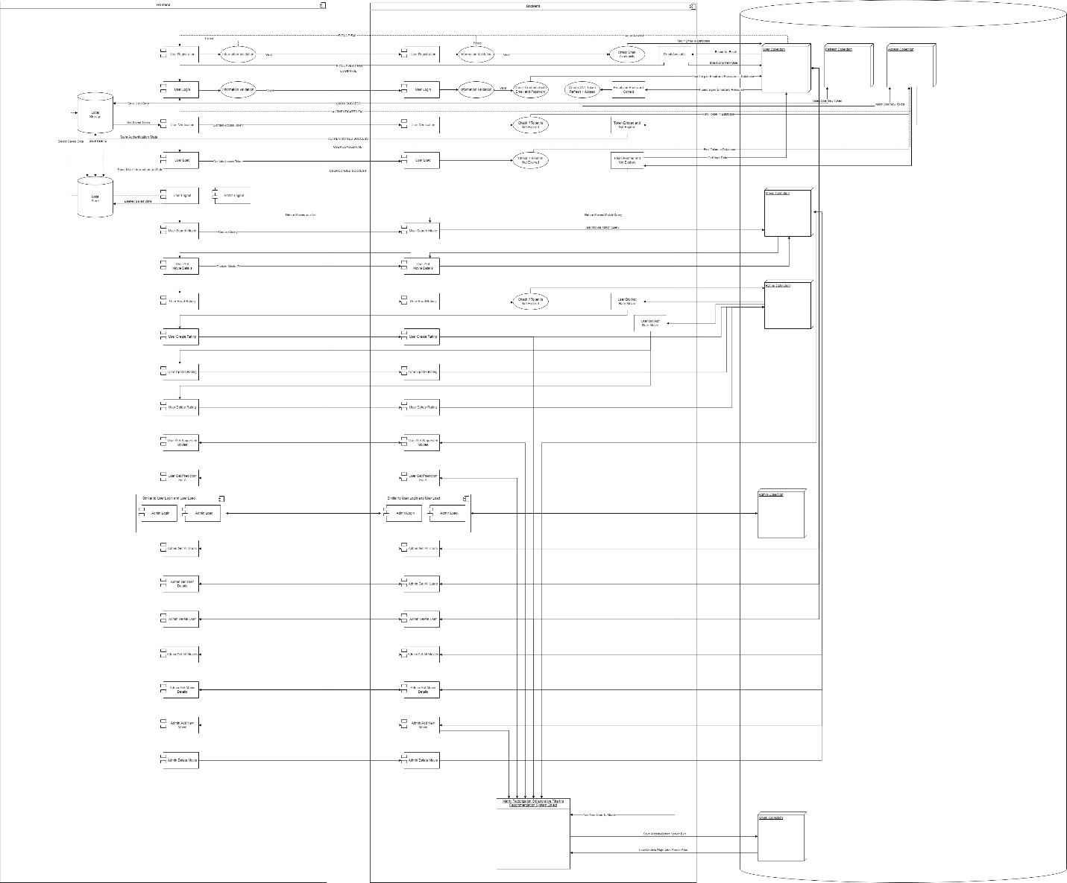

### Database Design

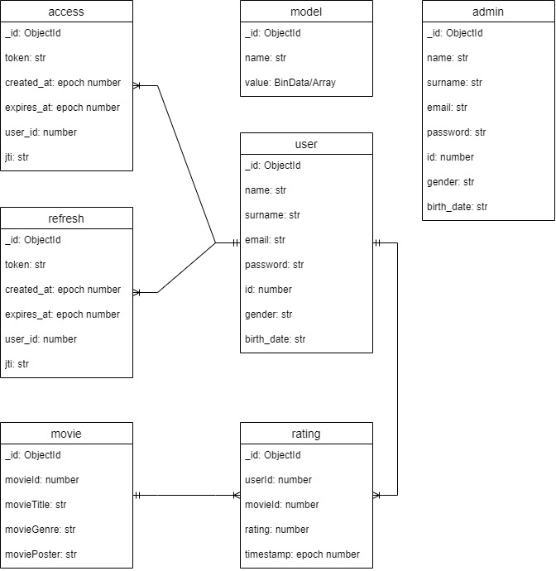

### Backend Design

Class Diagram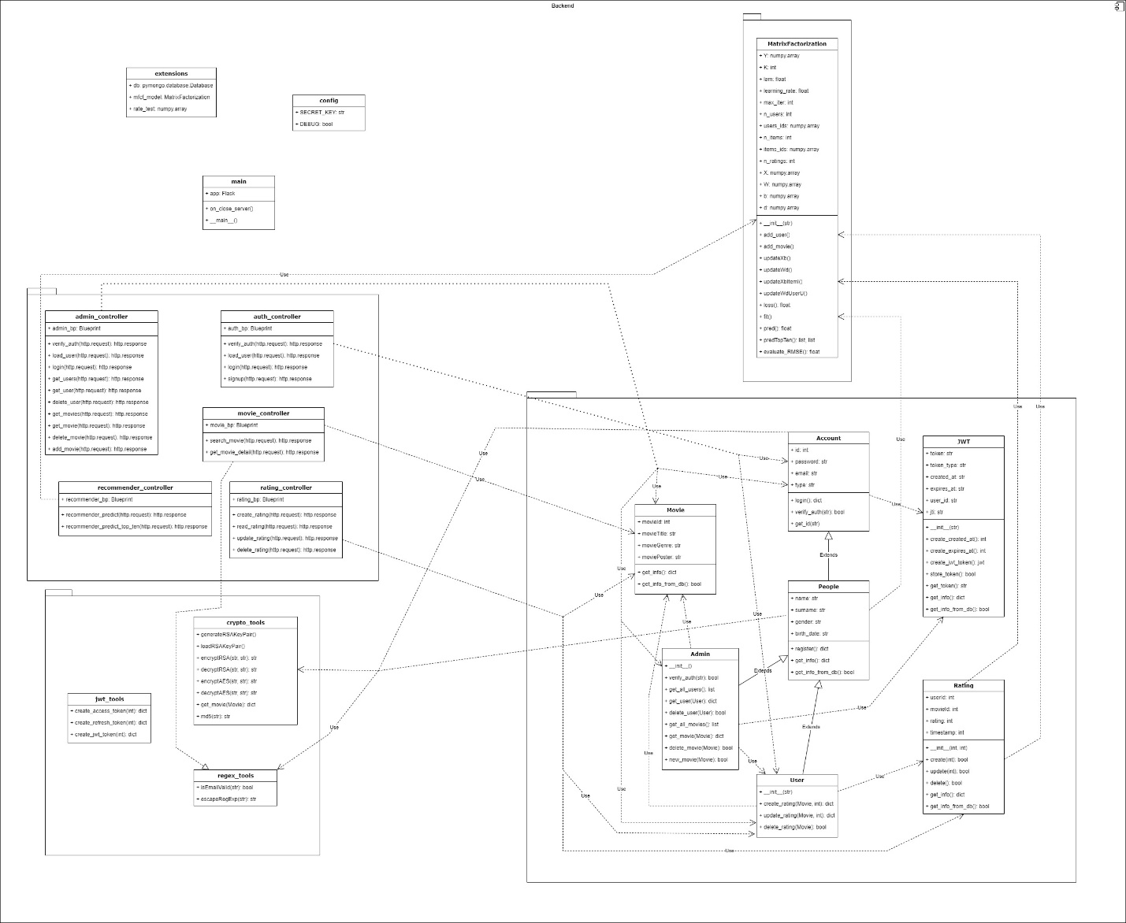



### Frontend Design

Redux Design Diagram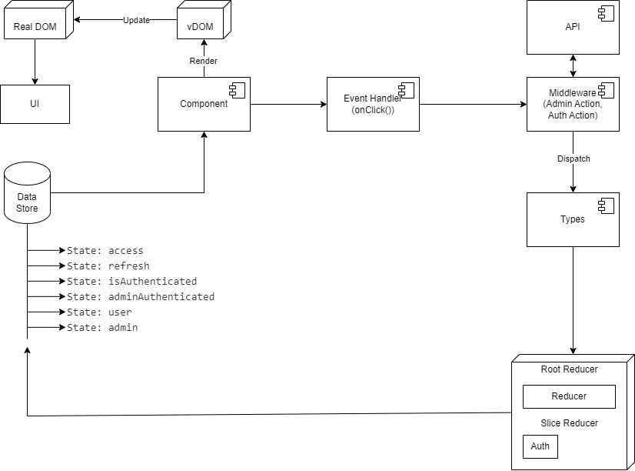

UI Layer Design Diagram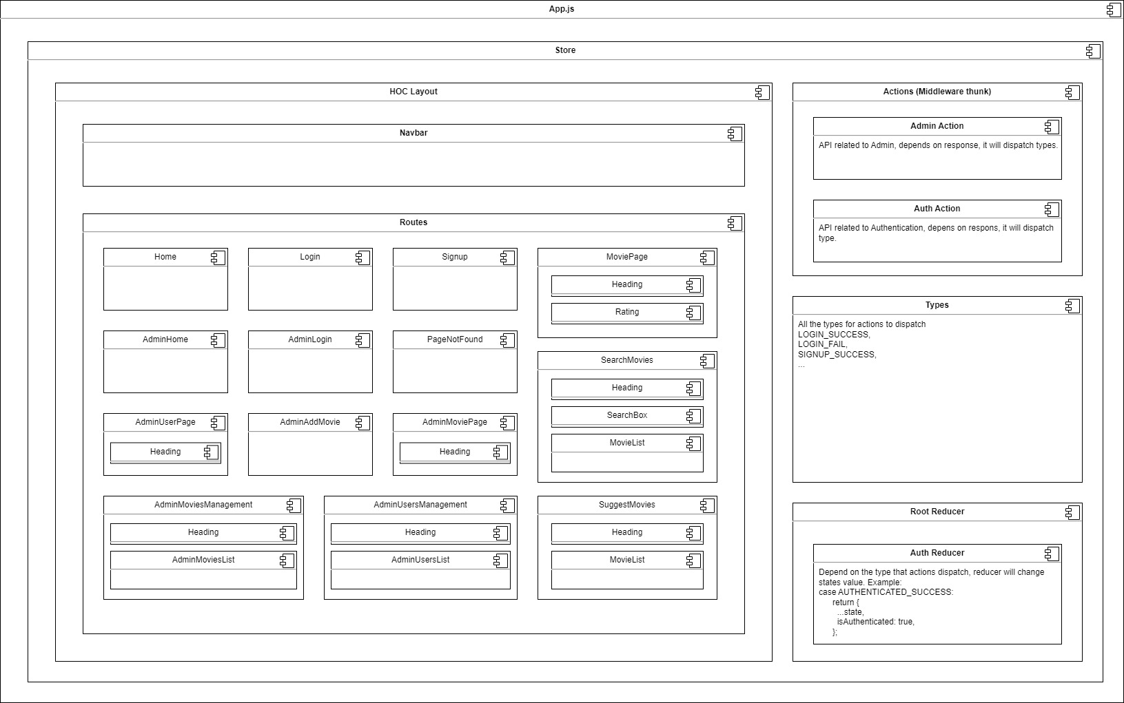

### Sequence Diagram

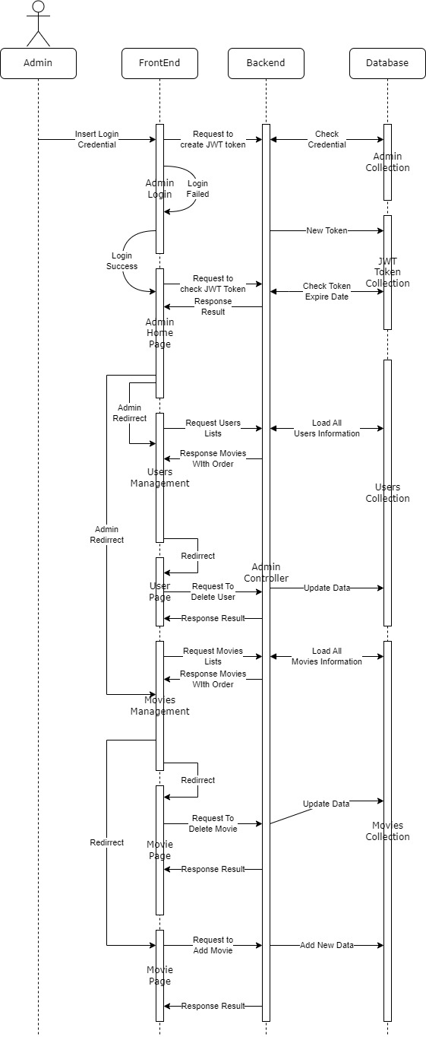

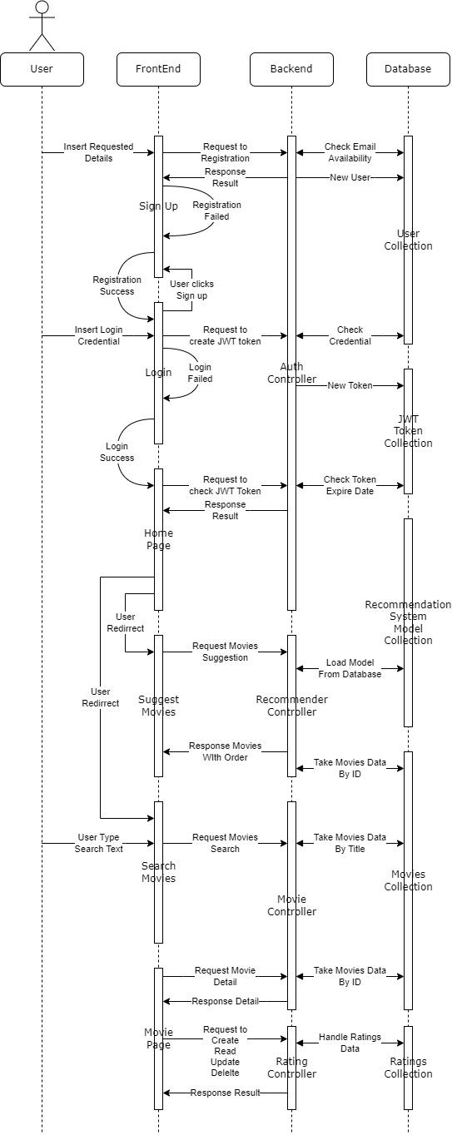

## Backlog refinement

From the Requirements Analysis, as a Product Owner, I have refined the backlog as follows.

### Epic

There are 3 epics corresponding to 3 components separated as stakeholders require in User Story 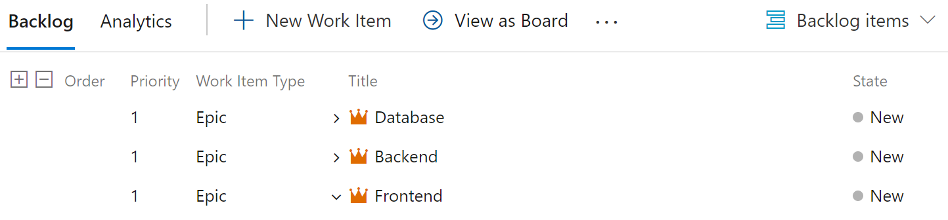

### Feature

From 7 Functional Requirements we analyzed before, I created 14 corresponding features. Each Functional Requirement will need 2 features for Backend and Frontend. They are: 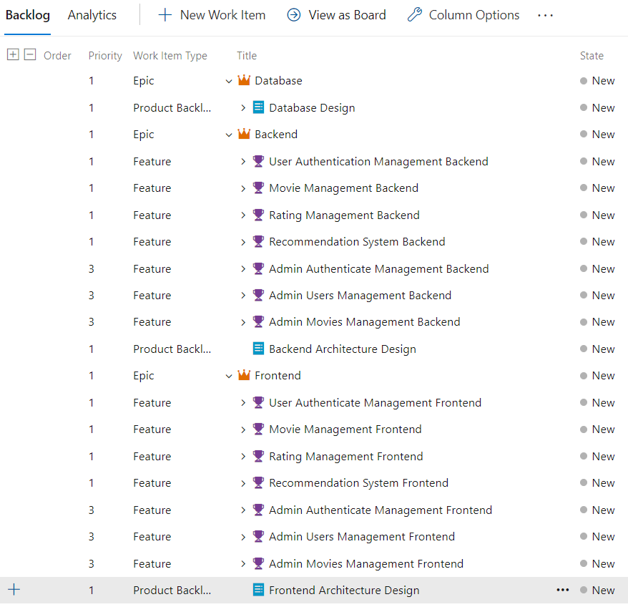

### Product Backlog

There are 48 product backlogs to finish feature and complete the system: 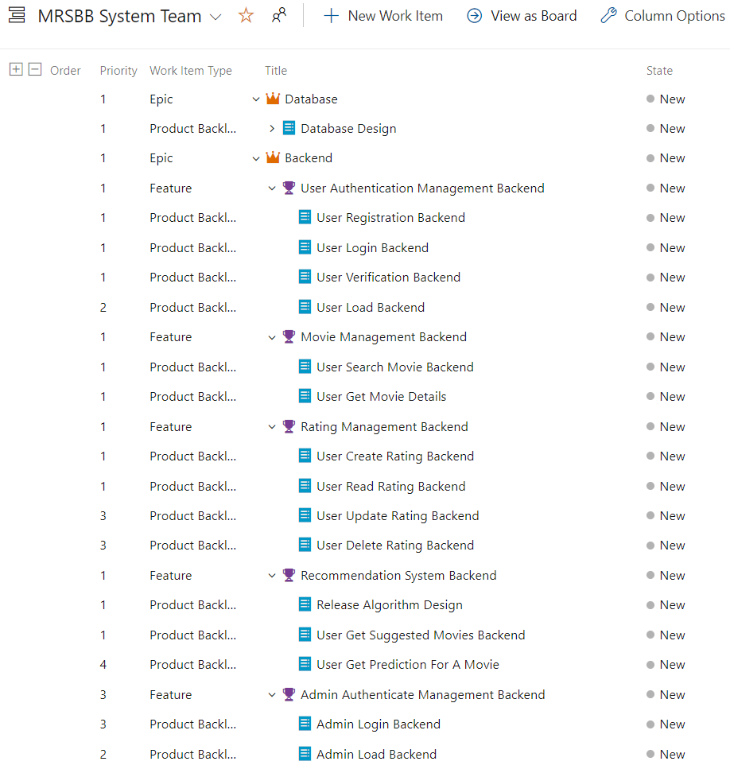

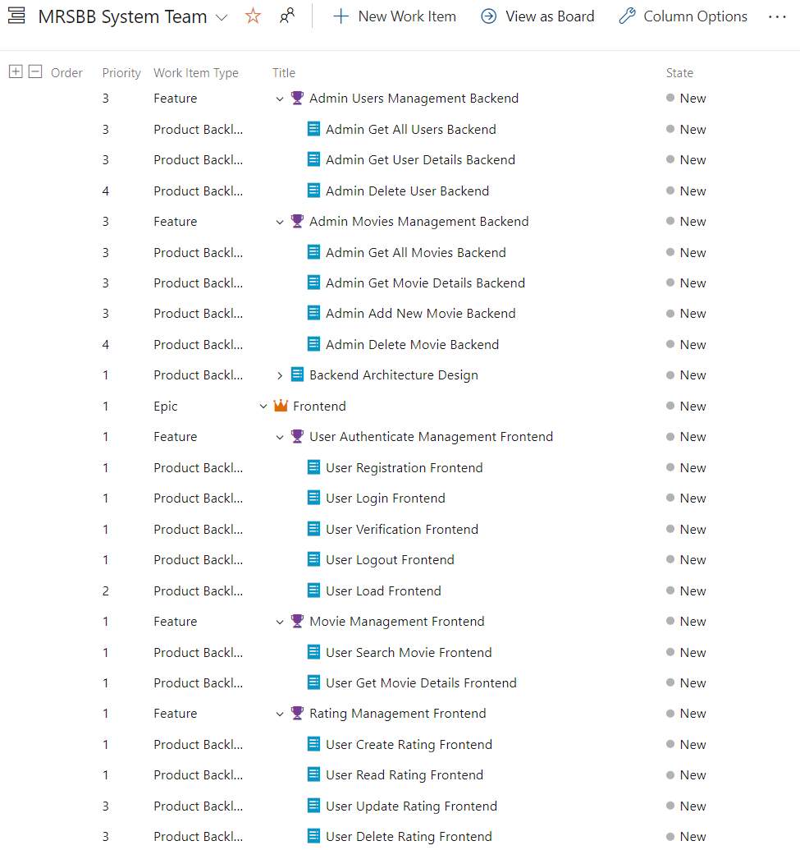

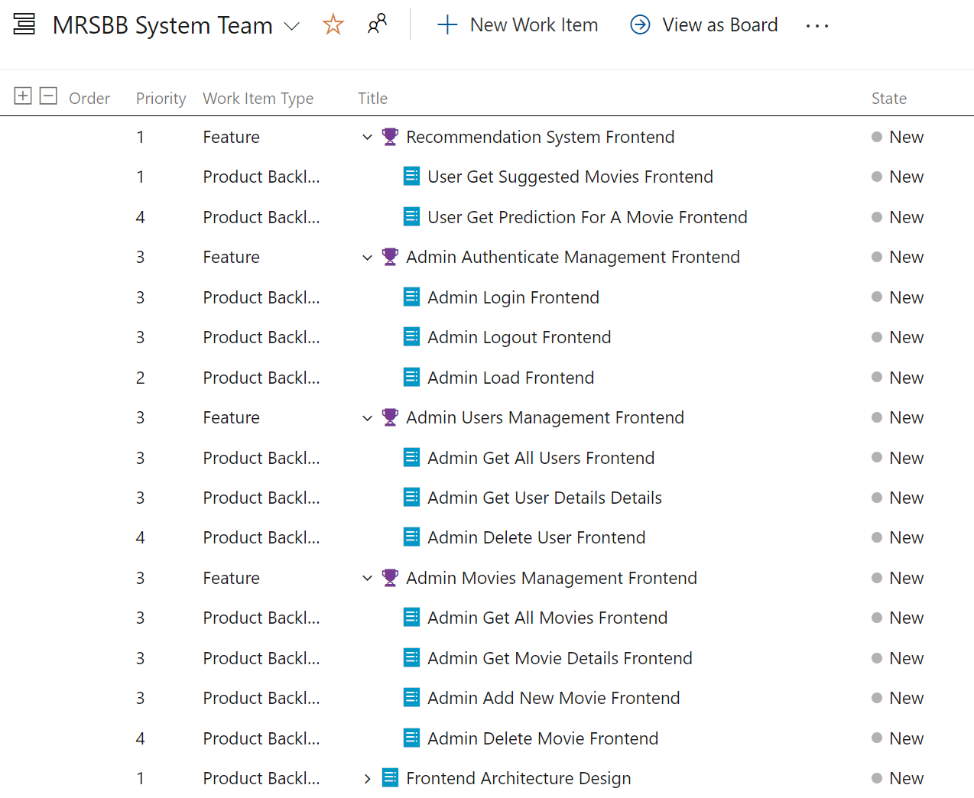

### Priority assignment

There are 4 priority levels in this project.

1. Must do
2. High Priority
3. Second-level Priority
4. Low Priority

First, all epics will have priority 1 since they must have for system deployment.

To be able to do Priority Assignment work, let's go into the essence of the system:

The purpose of the project is to study the Recommendation System and apply it in practice. So, FR.4: Recommendation System will need priority 1. However, FR.4.2 will have priority 4 because in real life situations, the user usually will not need an exact prediction rating for a specific movie.

There are 3 must have components for Recommendation System, they are:

* Users
* Movies
* Ratings

The more Users have Ratings on Movies, the more Recommendation System increase accuracy, so FR.1, FR.2, FR.3 will have priority 1. However, FR.3.3 and FR.3.4 will have priority 3.

All FR related to Admin will have priority 3. However, FR.6.3, FR.7.4 will have priority 4.

Finally, all product backlogs related to Design will have priority 1.

All Priority appears in section 7.3 in the column Priority.

## Project estimation (time and cost)

In this project, 1 Sprint is 5 working days long.

There are 4 Sprints:

1. Sprint 1 runs from 06/Mar/2023 to 10/Mar/2023 (5 working days).
2. Sprint 2 runs from 13/Mar/2023 to 17/Mar/2023 (5 working days).
3. Sprint 3 runs from 20/Mar/2023 to 24/Mar/2023 (5 working days).
4. Sprint 4 runs from 27/Mar/2023 to 31/Mar/2023 (5 working days).

Deployment cost: Azure Free Plan with 60mins using per day. 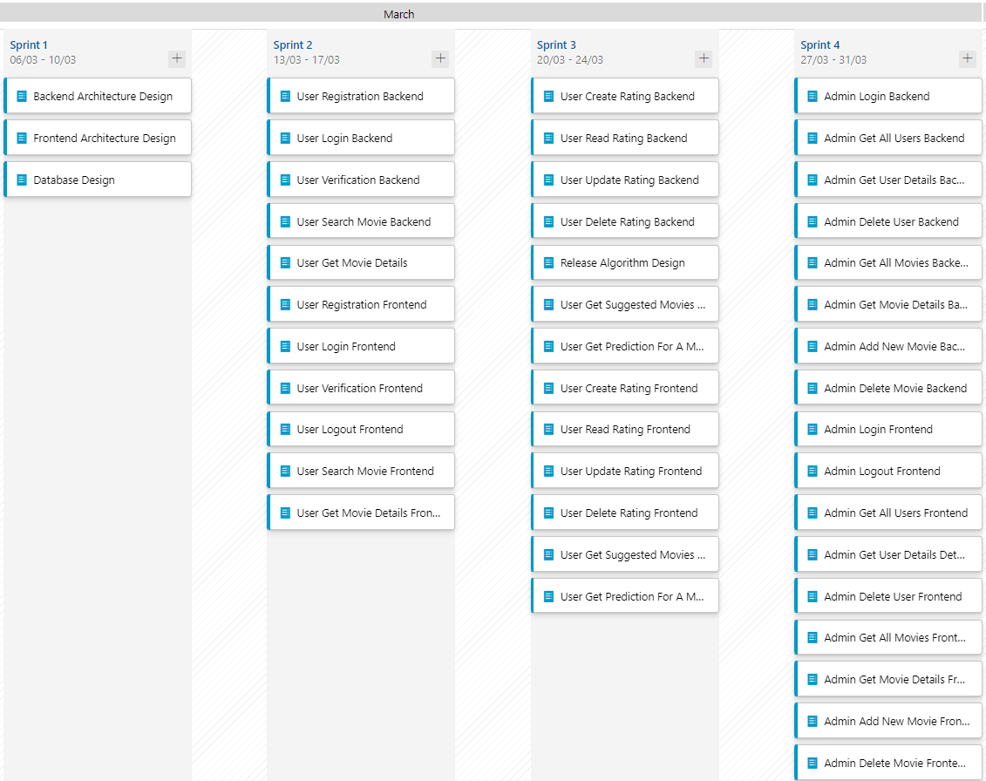

# Sprint cycles (2nd)

## Sprint 1

### Planning

In Scrum Planning, we will do task identification. The team identifies the tasks that need to be complete to deliver the product backlog items that are selected for the sprint.

In Sprint 1, tasks will be as below: 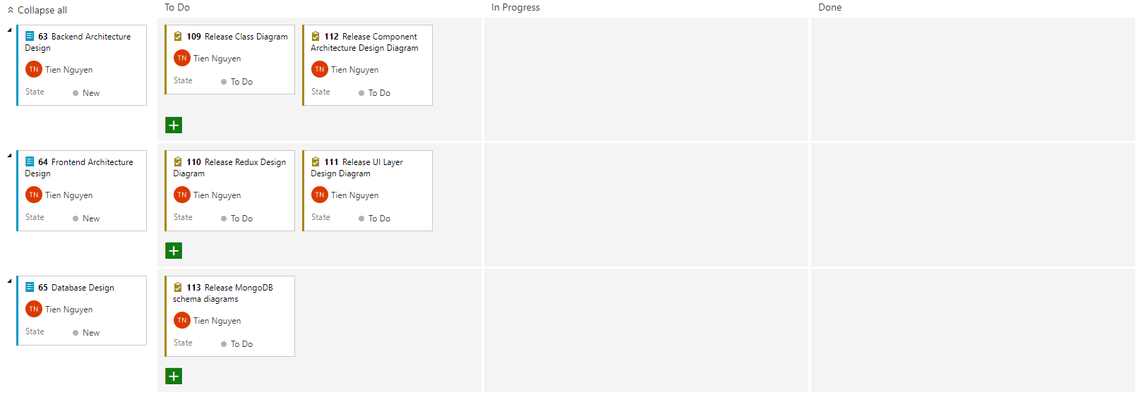

### Implementation

All the designs are located in section IV. Architectural Design.

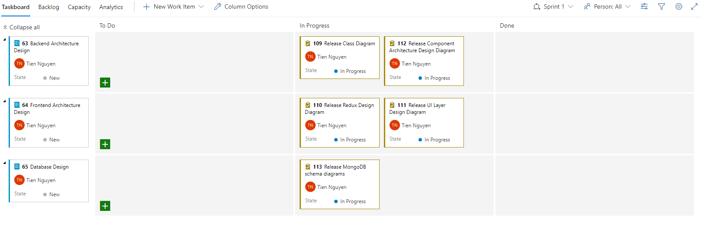

### Review

The most difficult task of a process is to have a good system design. With a good enough design after the Requirement Analysis process, the Development Team can accelerate quickly and complete the Functional Requirements on time and perform as expected. 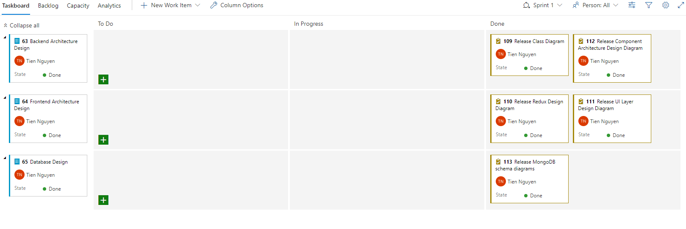

### Retrospective

Release Burndown Chart for Sprint 1

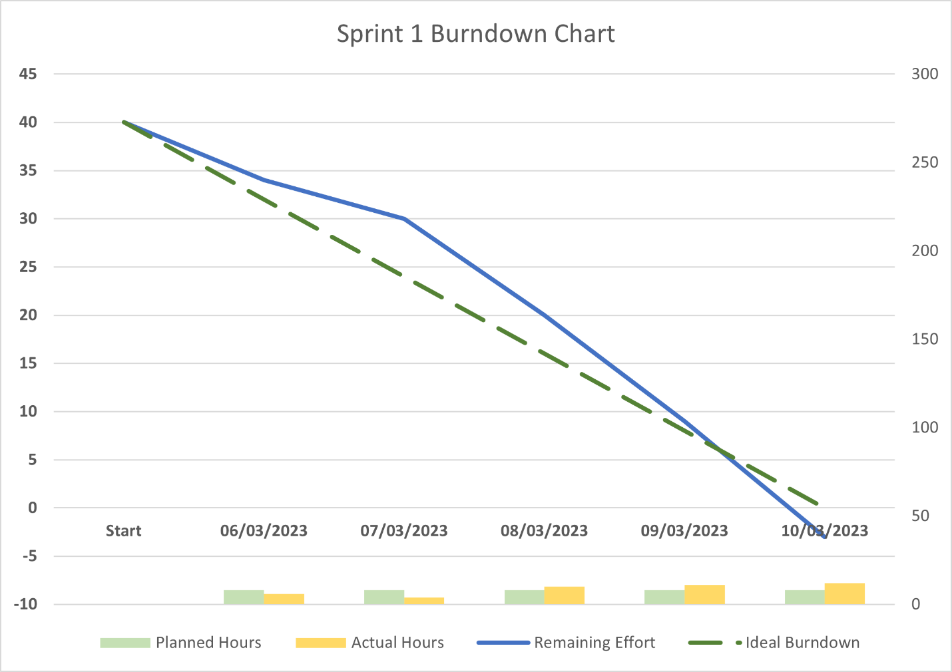

Design takes more time than how long the team expected, at Day 1 and Day 2, the team couldn’t find the right process to release design diagram. After Day 2, All the remaining days of the week, the team has to work overtime to release diagrams on time.

For more information, please refer to the file “Sprint_1_burndown_chart.xlsx”.

## Sprint 2

### Planning

In the Sprint 1, because the team did not manage time good enough, so they have to work overtime at some point while there are days that they did not take all 8 hours for works.

In Sprint 2, the team should take more attention for time management.

Task identified for Sprint 2:

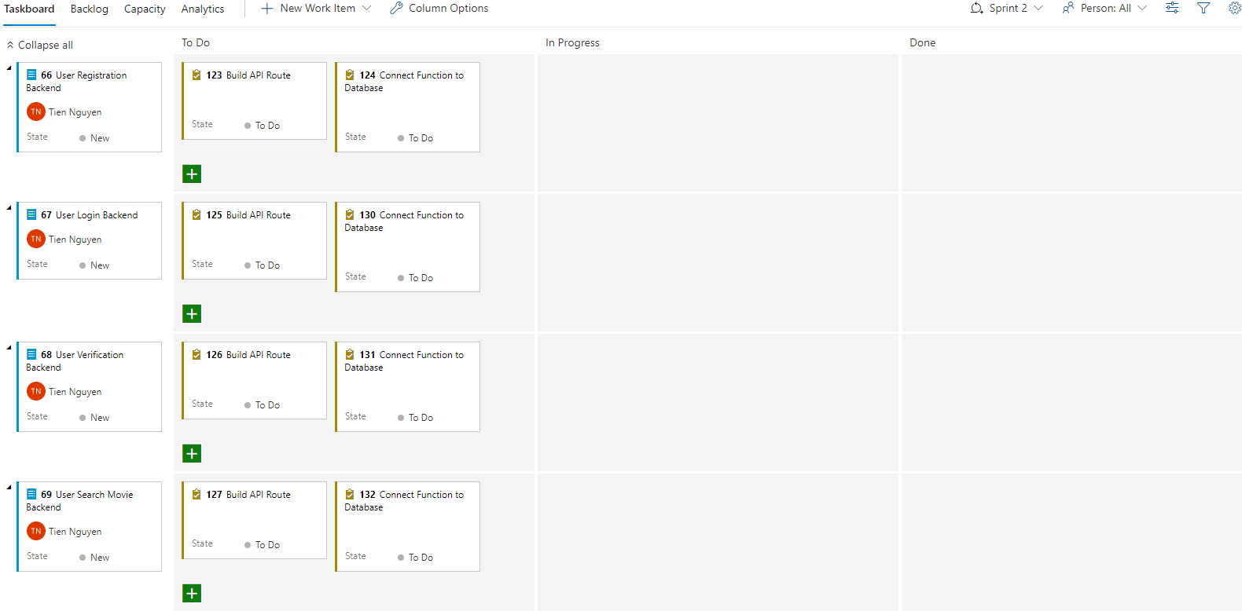

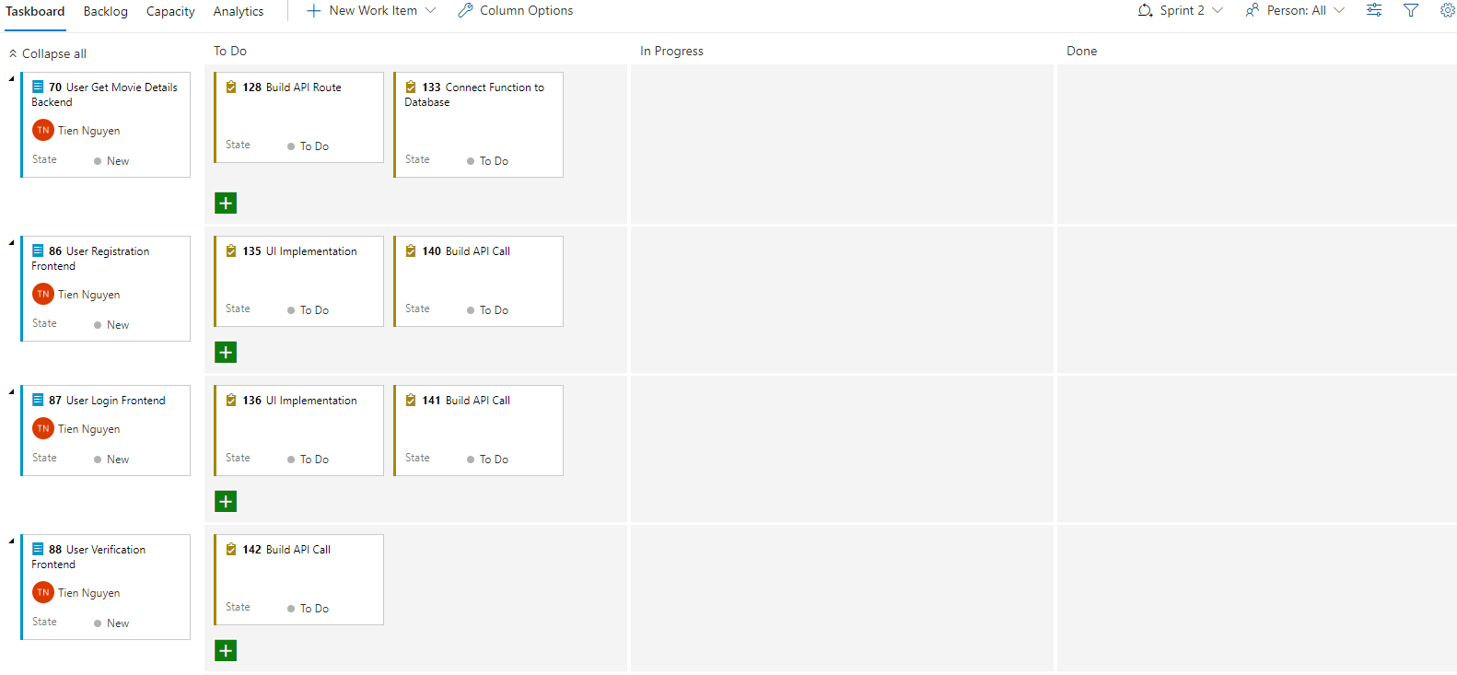

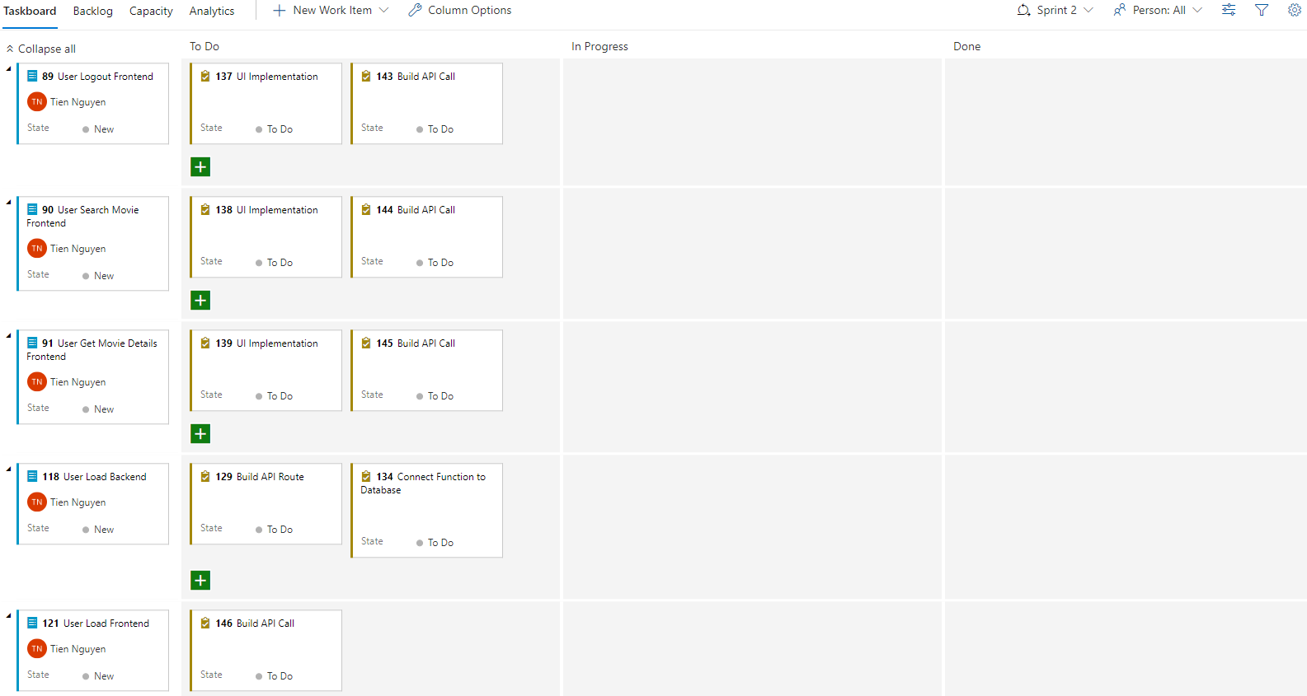

### Implementation

During the implementation, the team also did Unit Test using Postman after completing a feature but due to time rush, they were not able to complete the document for that. We will demonstrate testing in the following system testing section.

### Review

Thanks to the design of the system in Sprint 1, the implementation in Sprint 2 can run more smoothly, there are no backlogs remaining.

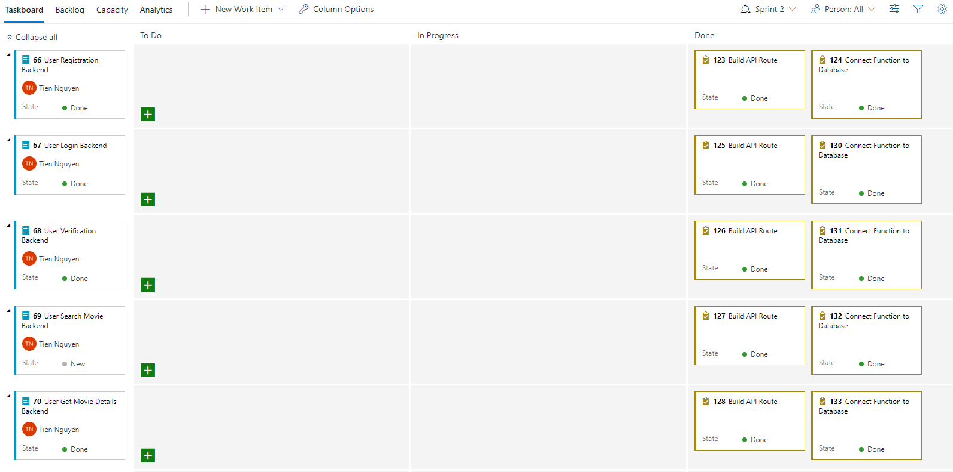

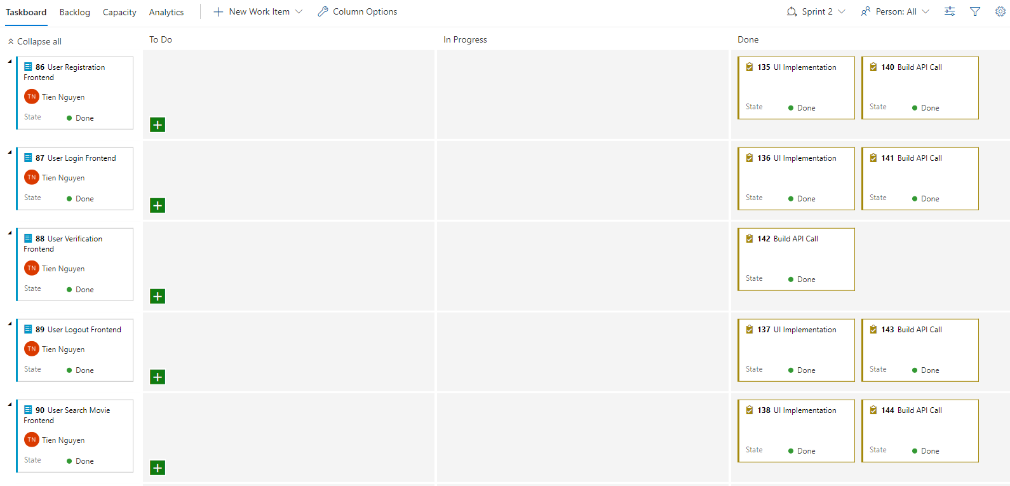

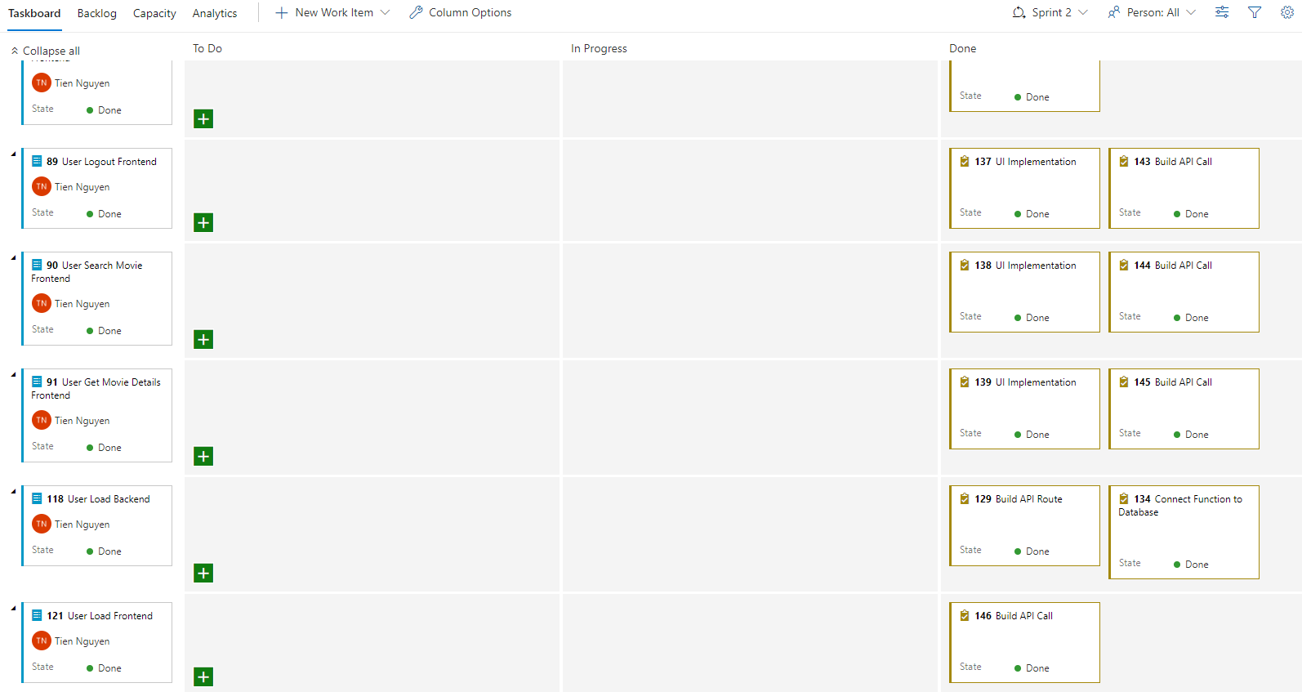

### Retrospective

Release Burndown Chart: 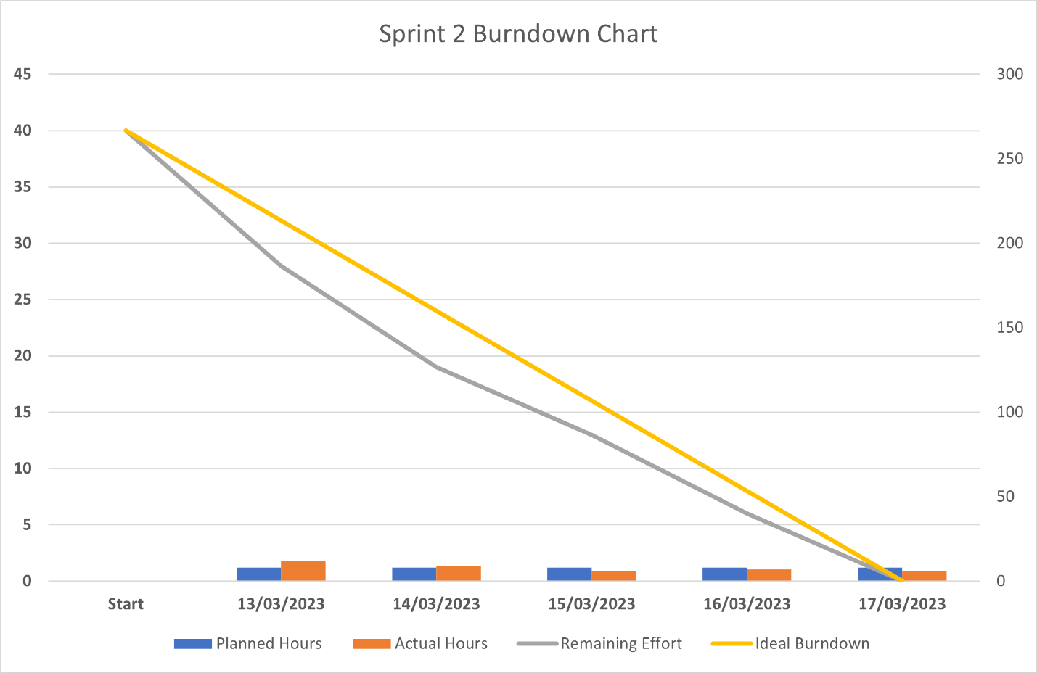

## Sprint 3

### Planning

Task identification for Sprint 3:

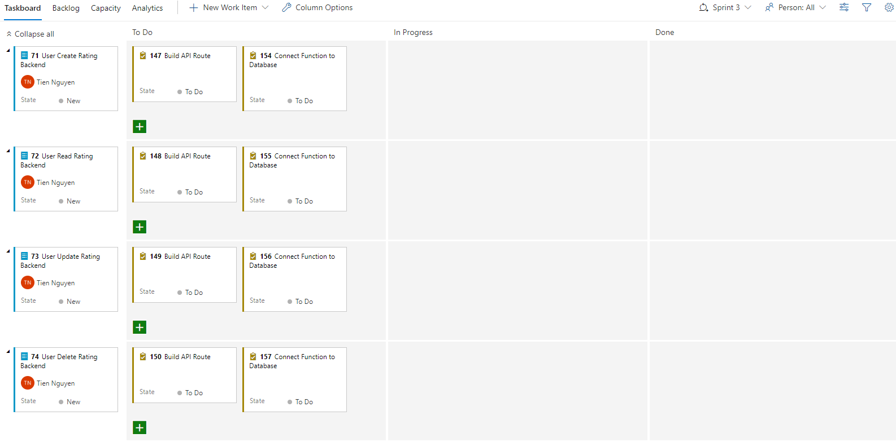

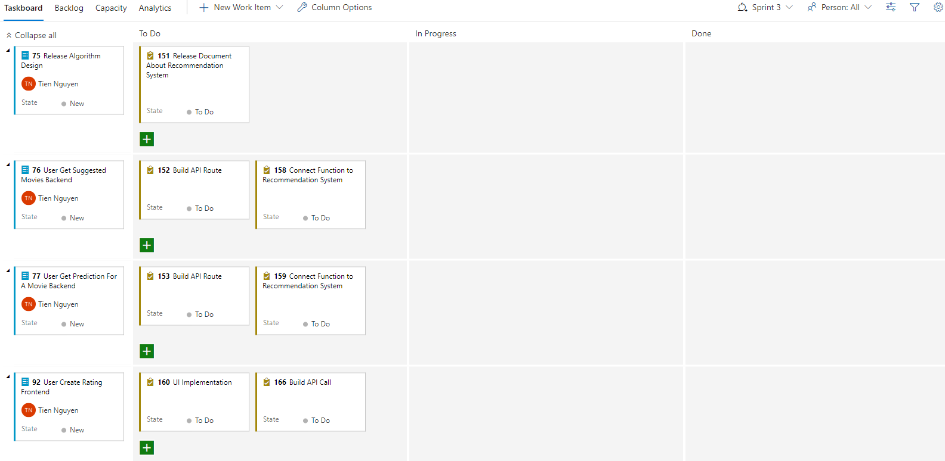

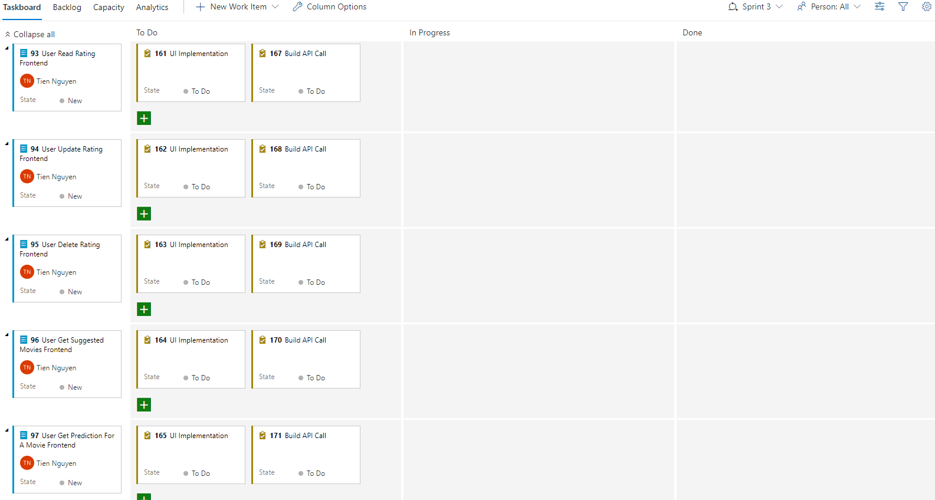

### Implementation

I reuse most of the parts that have been programmed from Scrum before, of course, it will have to be slightly modified due to changes in the Database and API structure in the Backend.

### Review

Implementation in Sprint 3 is quite smooth because most of the backlogs in Sprint 3 can be reused from the previous Scrum. However, there is still an unfinished backlog.

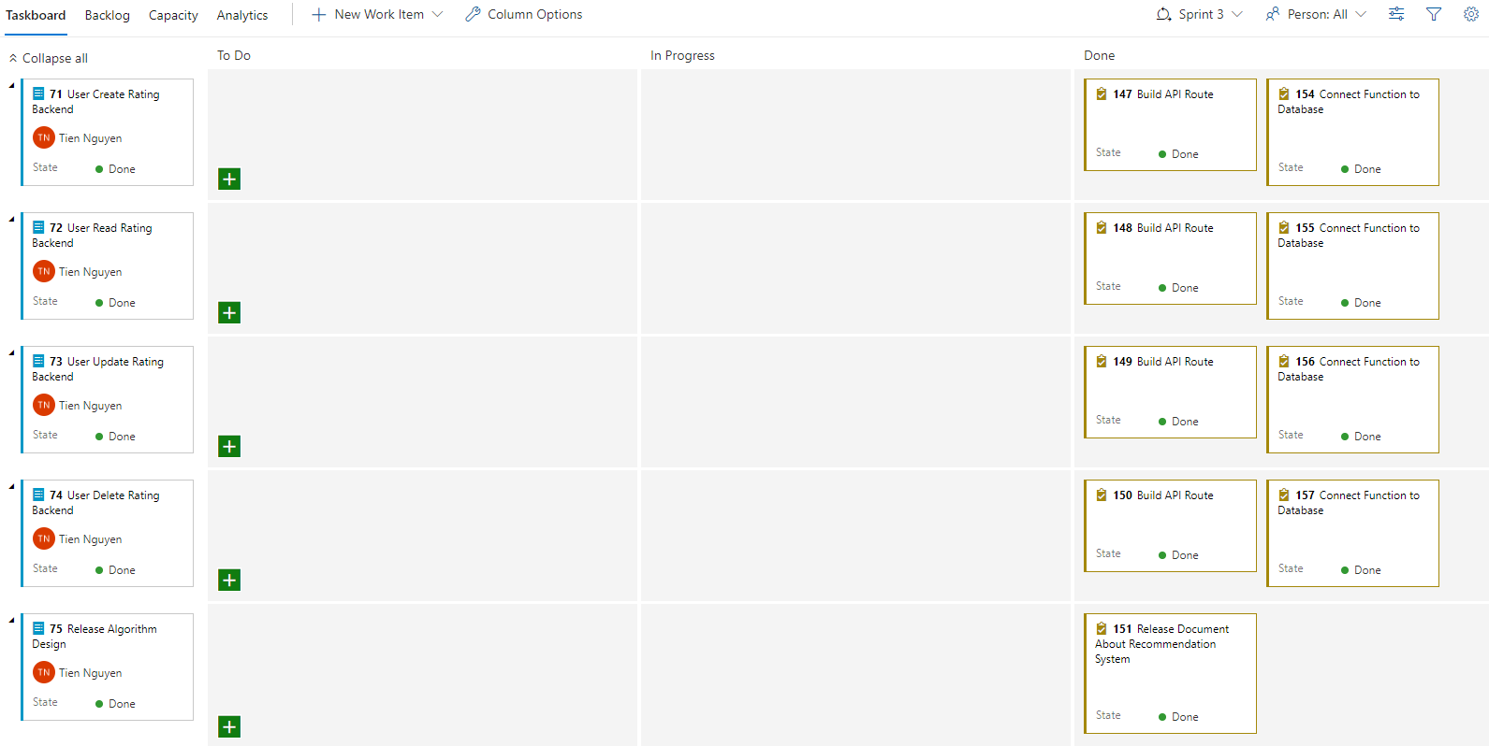

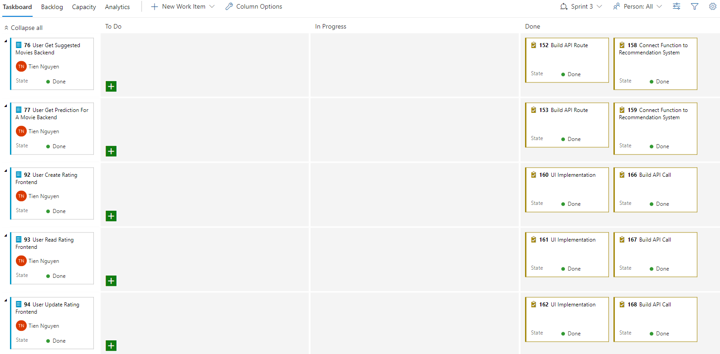

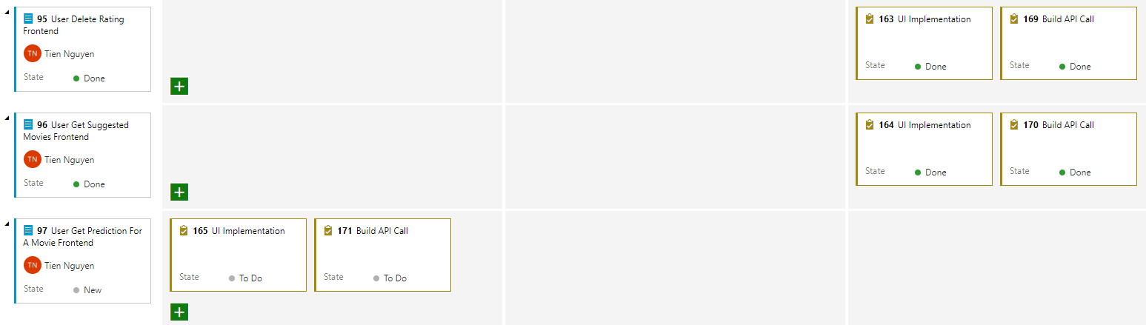

### Retrospective

Release Burndown Chart: 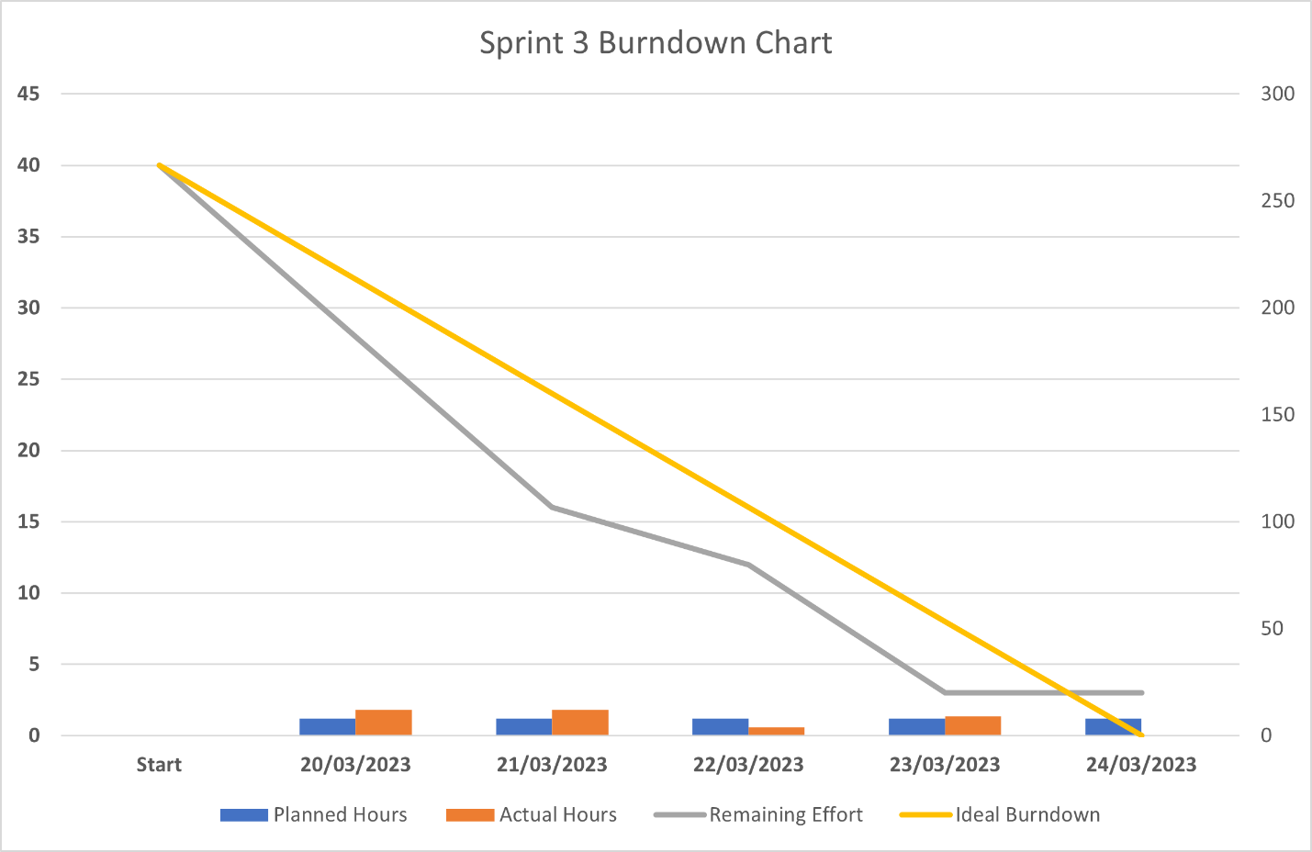

Looking at the Burndown Chart, we can see that the work was completed earlier than planned quite early in the beginning of the Sprint but by the end did not complete 100% of the Backlogs. Is there a problem with the team? This will be discussed in the Planning section of Sprint 4.

## Sprint 4

### Planning

Sprint 4 is the place with the most Backlogs in all 4 Sprints, but we still have to add Backlog not completed in Sprint 3. This backlog has Priority 4 so we'll still do it last if Sprint 4 doesn't have enough time.

Task identified for Sprint 4 as below.

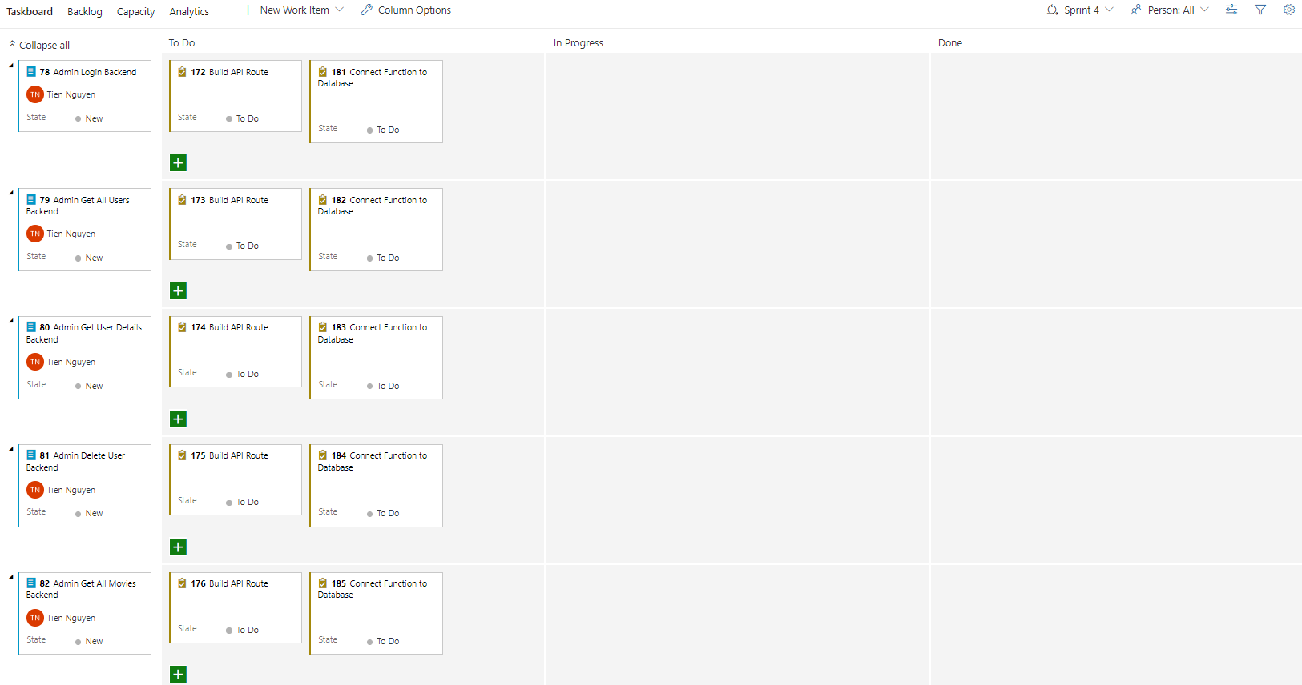

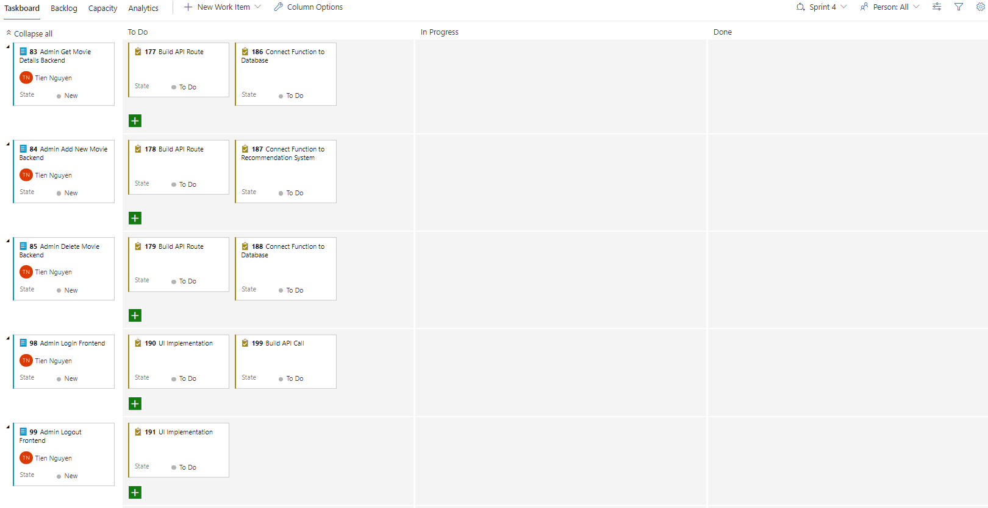

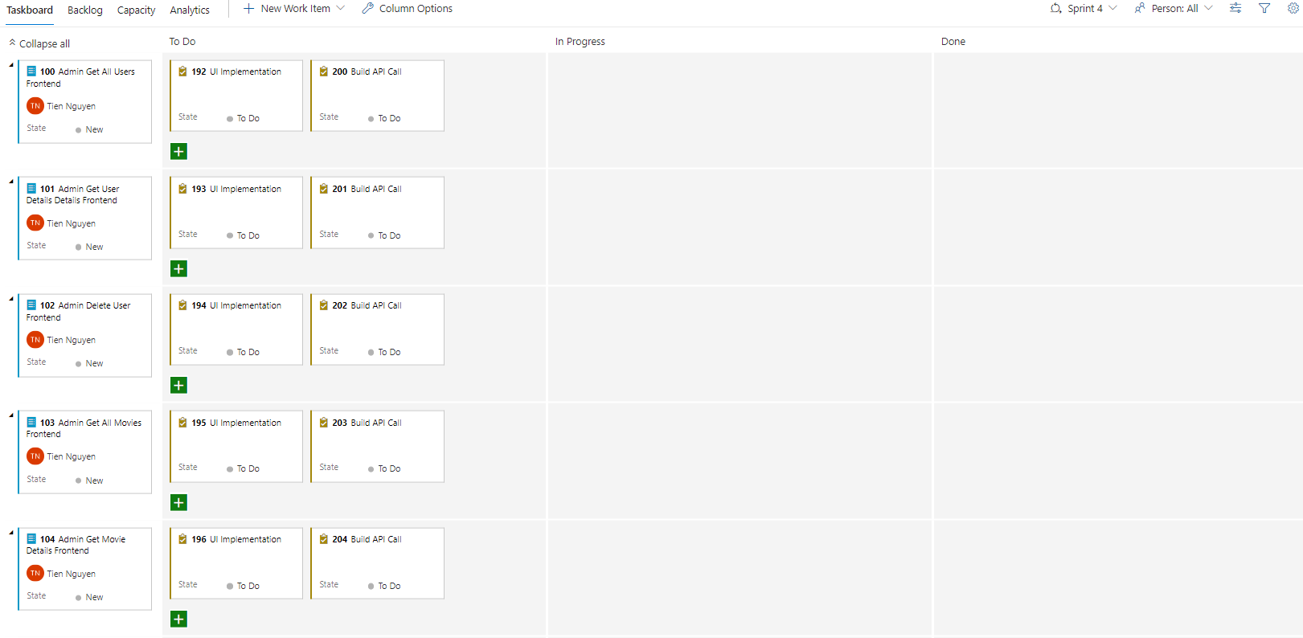

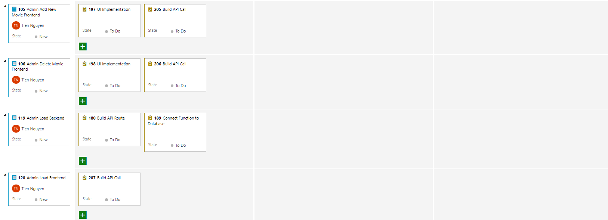

### Implementation

In Sprint 4, there are 3 Functional Requirements implemented are:

FR.5: Admin Authenticate Management

FR.6: Admin Users Management

FR.7: Admin Movies management

FR.5 is pretty similar to FR.1: User Authenticate Management so it will not take long time to implement.

The other two FRs (6 and 7) also don't take too much time because there's no need to focus too much on UX when the UI just needs to be usable, not too beautiful.

### Review

While all the Backlogs planned for Sprint 4 have been completed, the Backlogs from Sprint 3 have not yet been completed. However, the product can still be released because this Backlog is only in Priority 4, it's okay to have it or not.

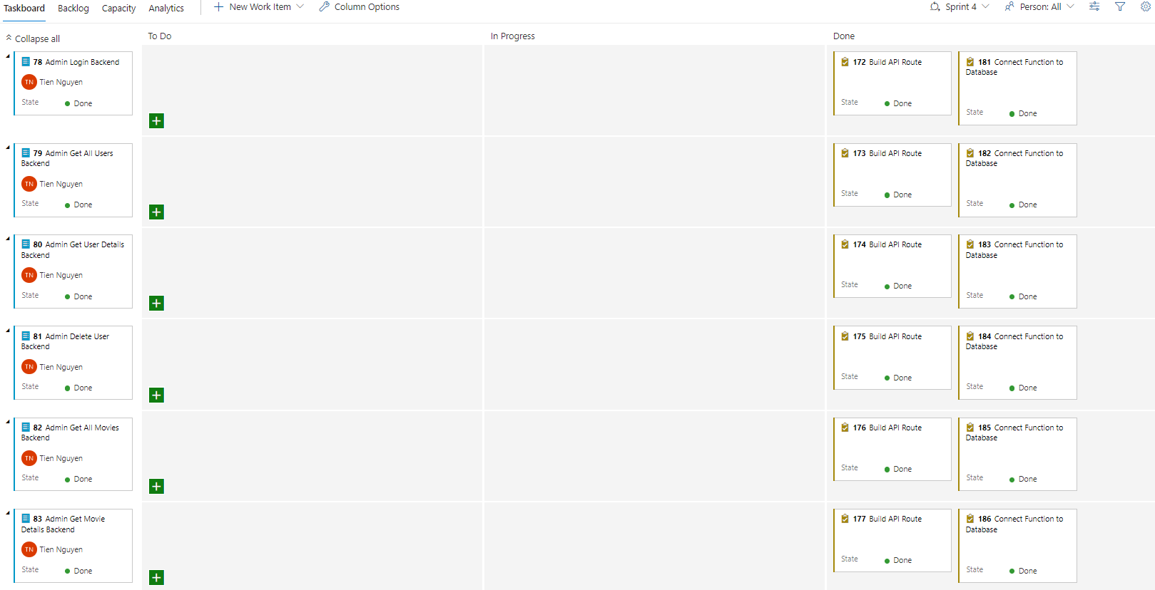

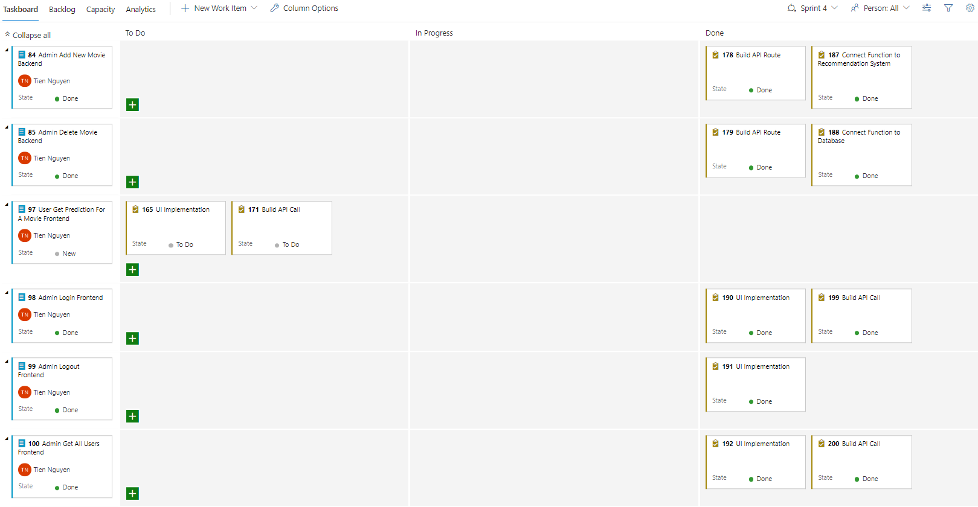

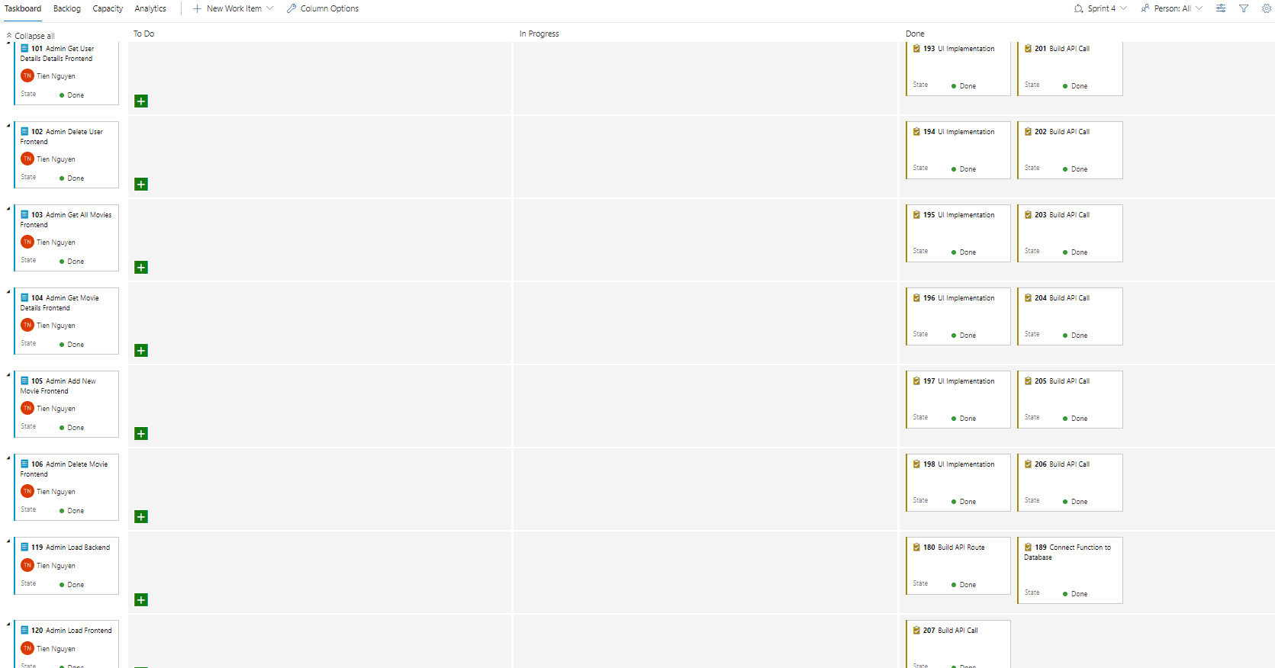

### Retrospective

Release Burndown Chart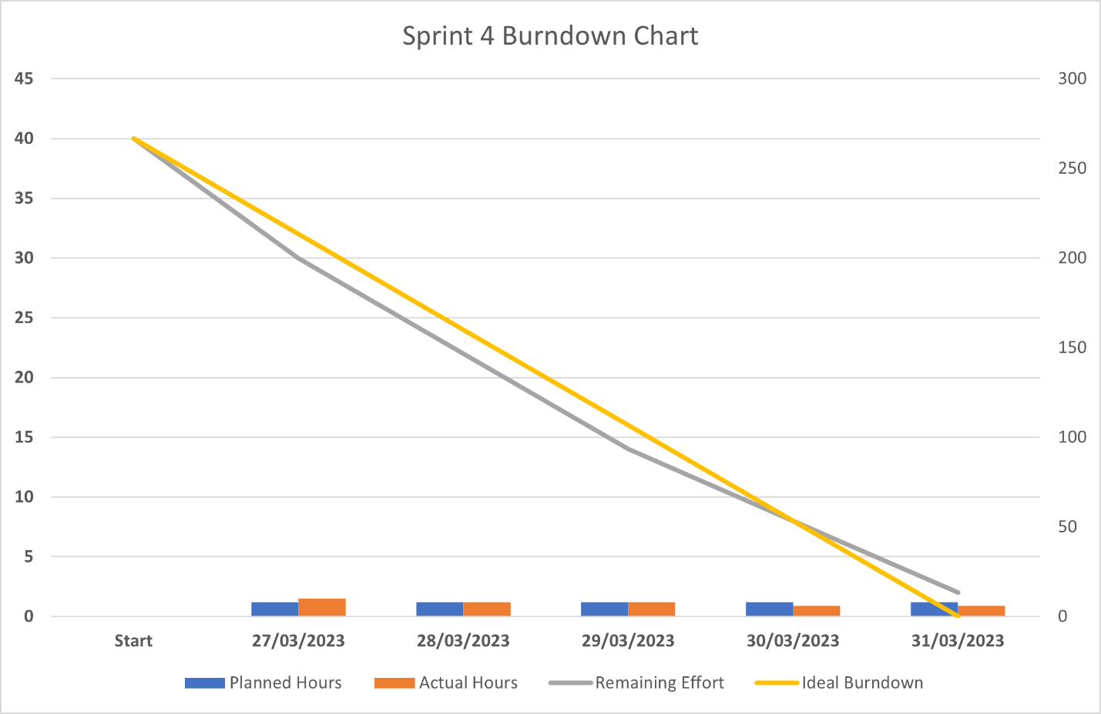

Looking at the Burndown Chart, we can see that the team has found the right pace and process for the project. The Backlogs are completed quite close to the time, not too late or too early like the previous times. Finishing too early is also not so good as finishing too late.

# Project closure

## Release Burn Up Chart

More Details in file “Release-Burn-Up-Chart.xlsx”

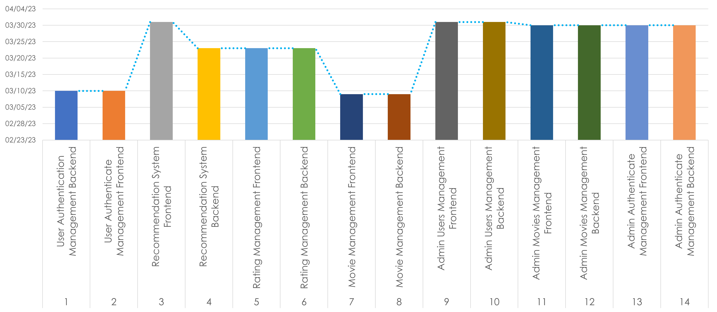

From the Burn Up Chart, we can see that most of the product's features are completed in the last Sprint. There are 4 features completed in the early stage, 3 features completed in the middle stage, and 7 features completed in the final stage.

## Verification test

Questions need answers in verification test:

* Are we building the product right?
* Does the software meet the specifications?

FR.1: User Authenticate Management:

FR.1.1: User Registration

Passed: Verify that all required fields are present, such as email, password, confirm password, …

Passed: Verify that user can successfully register with valid information.

Passed: Checking if a user can register with valid data only in mandatory fields

Passed: A user get registered should be allowed to login to the application.

Passed: A user tries to register an existing email then an error message should get displayed.

Passed: Verify if the registration form has all the fields required by the requirement document.

Passed: Verify that a user can navigate to Login if they have an account.

FR.1.2: User Login

Passed: Verify that a user can log in with valid credentials.

Passed: Verify that a user cannot log in with invalid credentials.

Passed: Verify that a user cannot log in with invalid email and password.

Passed: Verify that Browser will save login session at local storage.

Passed: Verify that a user can navigate to Register if they don’t have an account.

FR.1.3: User Verification

Passed: Verify that the user can successfully access the application with access token.

Passed: Verify that a logged in user doesn’t need to login again if they refresh the web page.

Passed: Verify that a logged in user can navigate to another function of application.

FR.1.4: User Logout

Passed: Verify that at any function of the application, user can press logout.

Passed: Verify that after user press logout, all the information of user and token will be deleted.

FR.1.5: User Load

Passed: Verify that after user get verified, user information will be loaded.

Passed: Verify that user information will not be in local storage.

Passed: Verify that user information will be in Data Store as a state.

FR.2: Movie Management:

FR.2.1: User Search Movie

Passed: User cannot search for movie with less than 3 characters.

Passed: User can search for movie with more than 3 characters.

Passed: User will get fast response when call multiple searches at a short time.

Passed: User will get a list of movies with covers for a clear view.

FR.2.2: User Get Movie Details

Passed: User can get all information about a movie such as: Title, Genre.

Passed: User can see movie cover.

FR.3: Rating Management:

FR.3.1: User Create Rating

Passed: User will be allowed to create a new rating when they see a movie page.

Passed: After user rated a movie, their W, d in machine learning model get trained.

FR.3.2: User Read Rating

Passed: When a user sees a movie page, they can see their existing rating.

Passed: If user didn’t rate that movie, it will display as blank star.

FR.3.3: User Update Rating

Passed: Verify if update rating function will only appear with existing rating.

Passed: Verify if update rating will change their W, d in machine learning model.

Passed: User should see updated rating value after server confirm.

FR.3.4: User Delete Rating

Passed: Verify if delete rating function will only appear with existing rating.

Passed: User should see blank rating star after server confirm rating is deleted.

FR.4: Recommendation System:

FR.4.1: User Get Suggested Movies

Passed: Verify if user can get a list of suggested movies.

Passed: Verify there is no rated movie in the list.

Passed: Evaluate model with training set, testing set.

FR.4.2: User Get Prediction for A Movie

Passed: API call for this function work.

FR.5: Admin Authenticate Management:

FR.5.1: Admin Login

Passed: Same as User Login

Passed: User credentials cannot be used to be login as admin.

Passed: Admin credentials cannot be used to be login as user.

FR.5.2: Admin Logout

Passed: When an admin press logout, there is no information left in the local storage.

Passed: When an admin press logout, there is no information left in the data store.

FR.6: Admin Users Management:

FR.6.1: Admin Get All Users

Passed: Admin can see all users in the database.

Passed: Click on the list will direct admin to see a specific user information.

FR.6.2: Admin Get User Details

Passed: Admin can see all information about user.

Passed: Admin cannot know user password nor see user encrypted password.

FR.6.3: Admin Delete User

Passed: Admin can only delete existing user.

Passed: Admin will access this feature in the specific user details.

FR.7: Admin Movies management:

FR.7.1: Admin Get All Movies

Passed: Admin can see all movies in the database.

Passed: Click on the list will direct admin to see a specific movie information.

FR.7.2: Admin Get Movie Details

Passed: Admin can see all information about movie.

FR.7.3: Admin Add New Movie

Passed: Admin can access this feature through FR.7.1.

Passed: After pressing a button, admin will turn into a page where they can fill the new movie.

FR.7.4: Admin Delete Movie

Passed: Admin can only delete existing movie.

Passed: Admin will access this feature in the specific movie details.

## Validation test

Questions need answers in validation test:

* Are we building the right product?
* Does the software meet the user requirements?

Can this application suggest movies to the user? Accepted

How does this application suggest movies to users? By a machine learning model. Accepted.

To get more accurate suggestions, what does a user need to do? Give more ratings to more movies, update their rating or delete existing ratings.

To rate a movie, what does a user need to do? Create an account, login and access a movie page.

How can a user access a movie page? Through Movie Search or Movie Suggestion.

Basically, all the requirements of the stakeholders for the application have been met and the validation test passed.

## Operation plan and Deployment order

Target cost: free plan.

There are 3 components in this project:

* Database
* Backend
* Frontend

Frontend will only work when it gets response from Backend.

Backend will only work when it gets data from database to process.

So, the deployment order will be as follows:

1. Database
2. Backend
3. Frontend

The cost plan will aim to free, details will be in the next sections.

## Database Deployment

With a logged in user at MongoDB Atlas, we can deploy a free database:

The cost plan is M0.

The provider is Azure.

The region is Netherlands (westeurope).

Name is MRSBBDB.

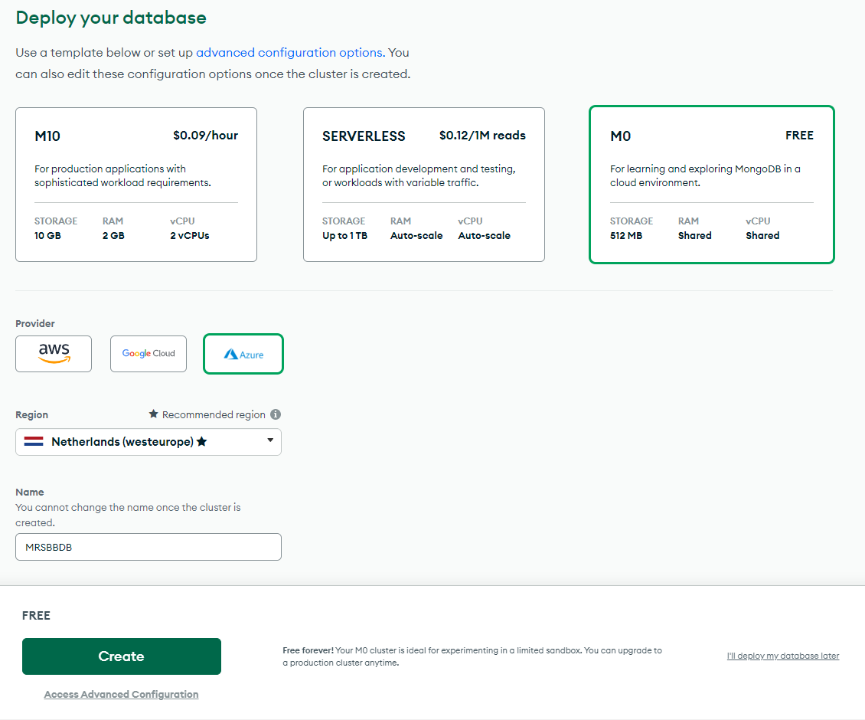

Next, we have to set up an authenticate method, in this project, I choose username and password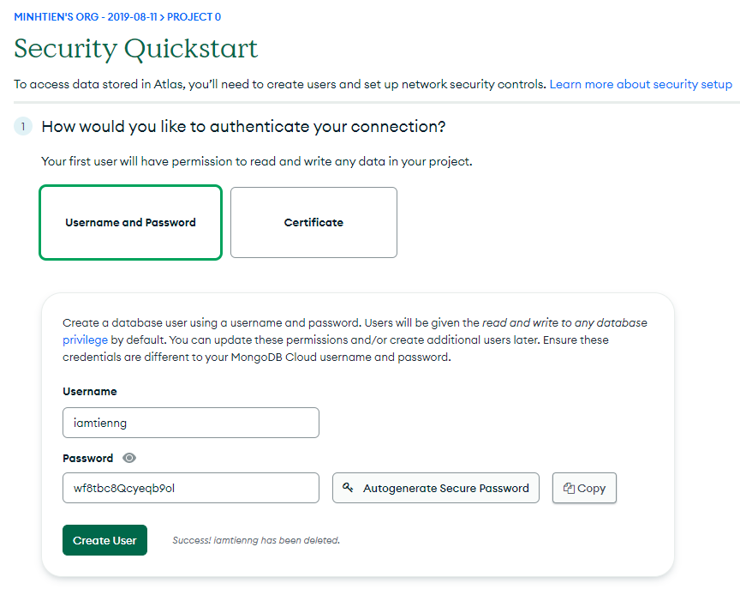

Next, we have to setup IP Access List, 0.0.0.0/0 is anywhere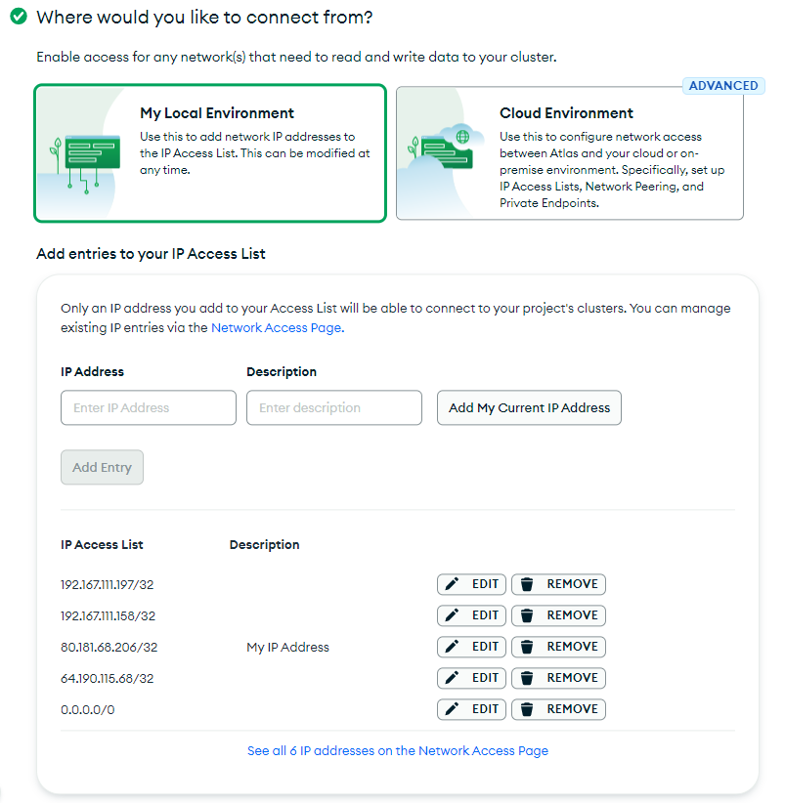

Next, we connect the database with MongoDB Compass to setup initial data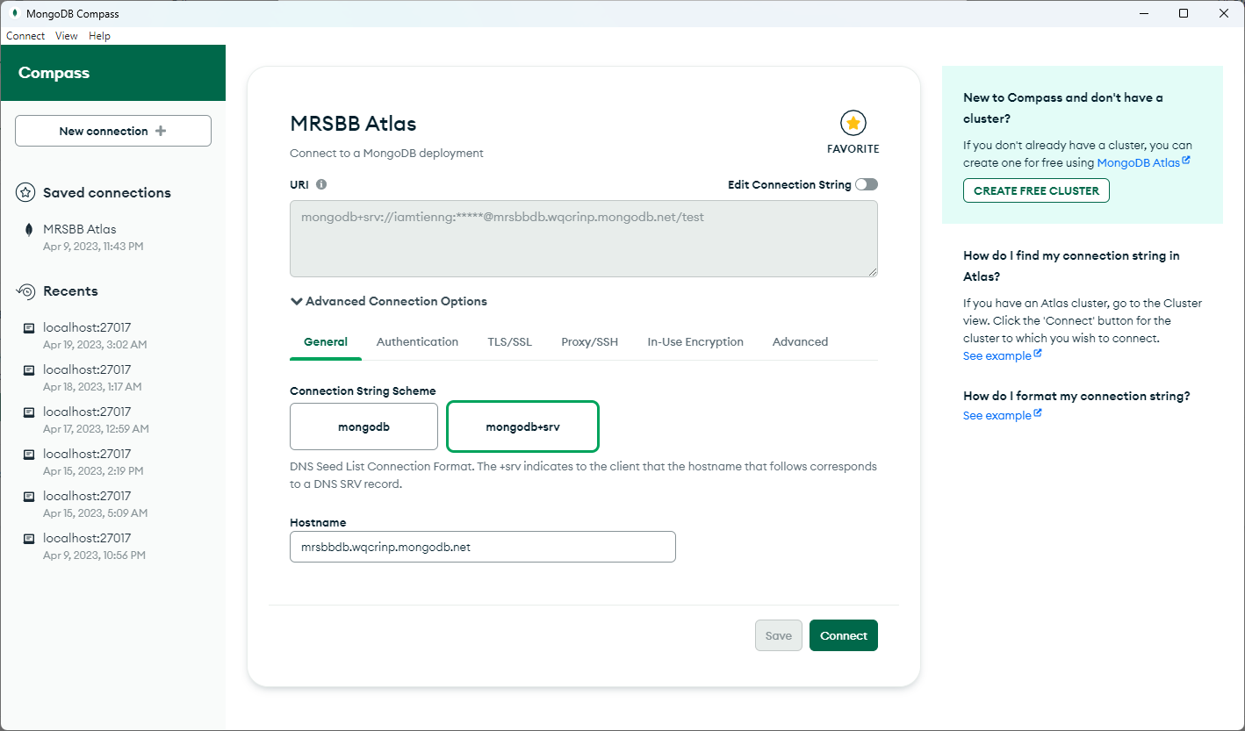

Next, we create 7 collections and import all data in the json files in Database directory:

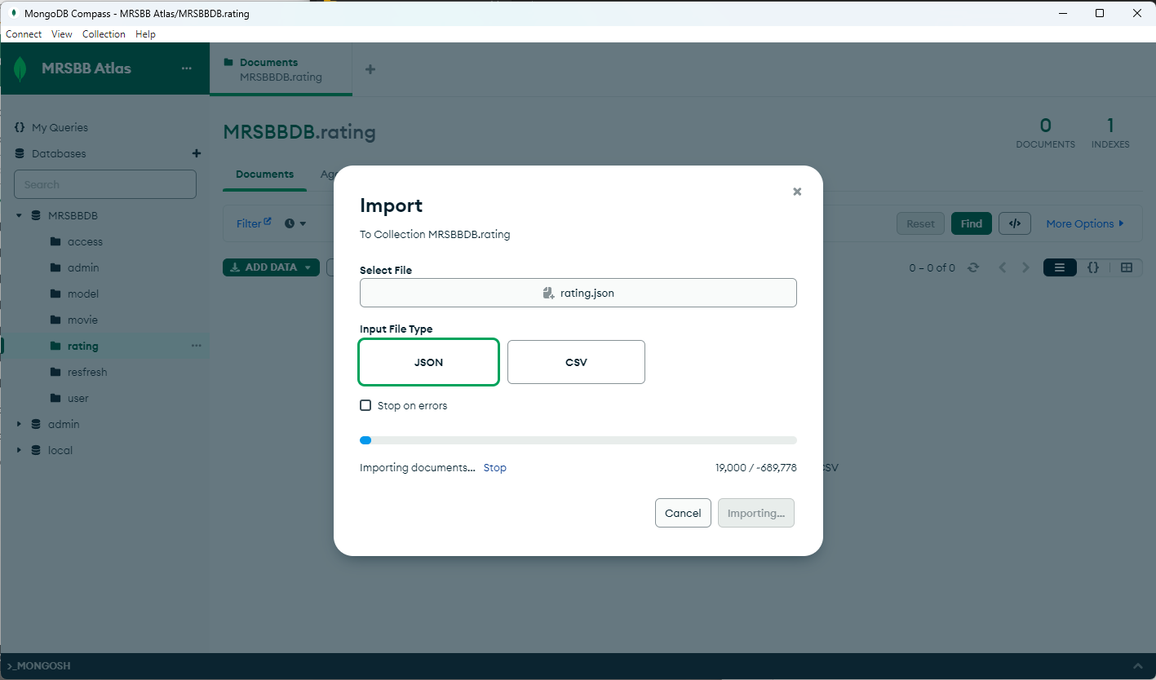

For Backend to access this deployed database, we have username, password and database url.

## Backend Deployment

First, we need to setup requirement.txt file, this file will contain all the names of the packages and their respective versions that are needed for backend application. My requirement.txt file is:



With this requirement.txt file, a package-management system written in Python called Pip will install automatically when we set up docker container.

Next, we need to set up the Dockerfile, my Dockerfile will be as follows:



Before we move to next step, be sure change the localhost database to the database we deployed in the file extensions.py:



Also, for deployment on azure, add this to Flask app main:



Run this command below in the terminal, we will build a docker image.



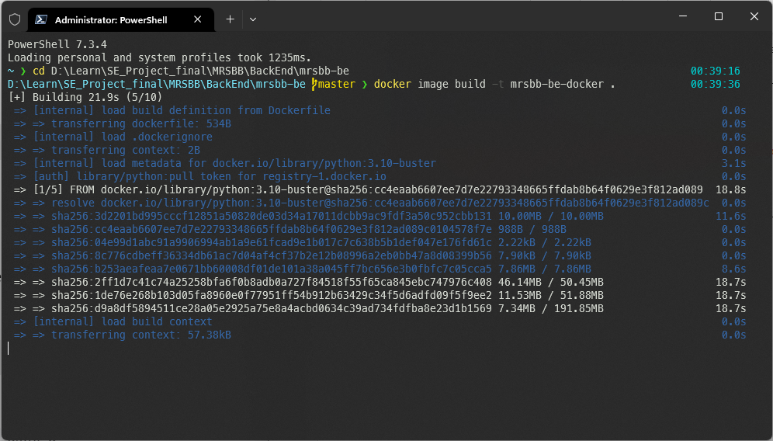

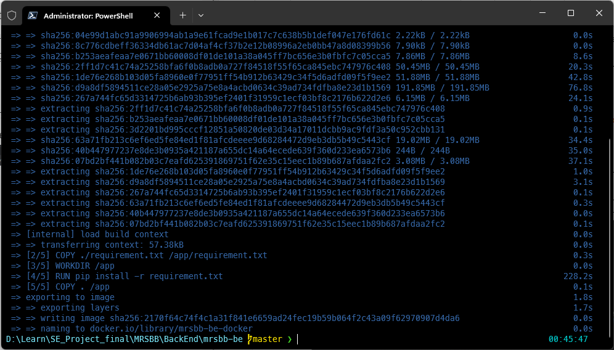

After having a docker image, we need to add tag which will be our docker username so we can push the image to docker hub with this command:



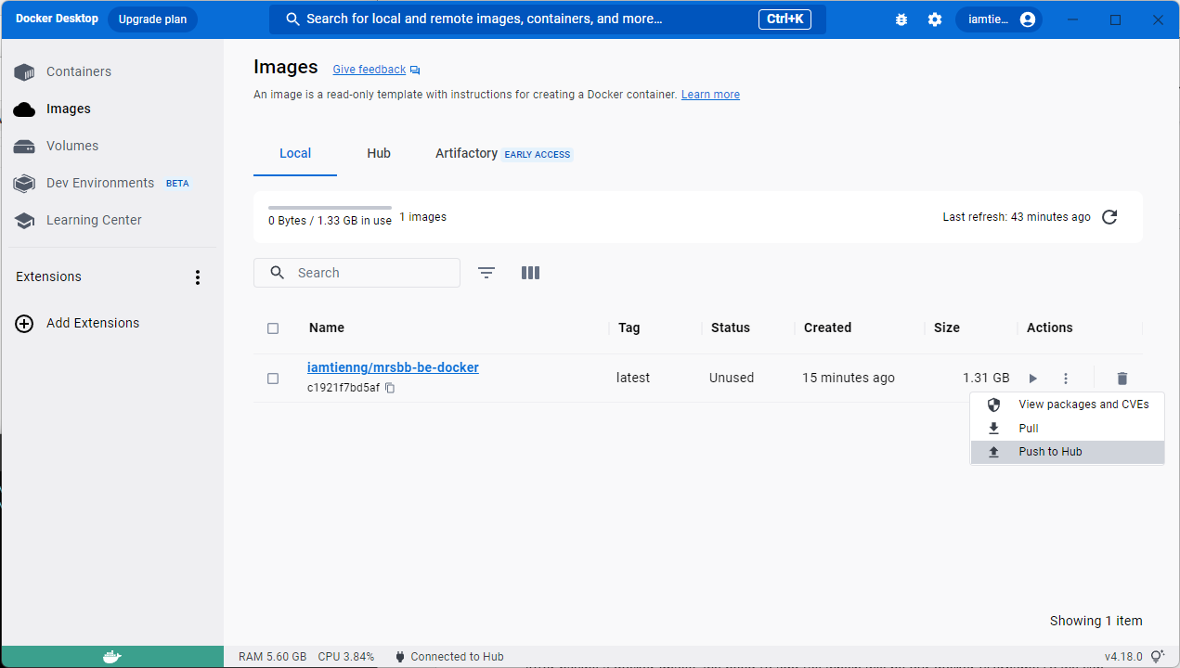

Create a resource group on Azure portal:

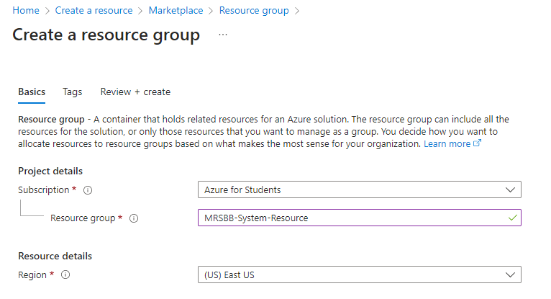

Create Web App on Azure portal:

The pricing plan is Free F1.

Domain name will be mrsbb-system-be.azurewebsites.net

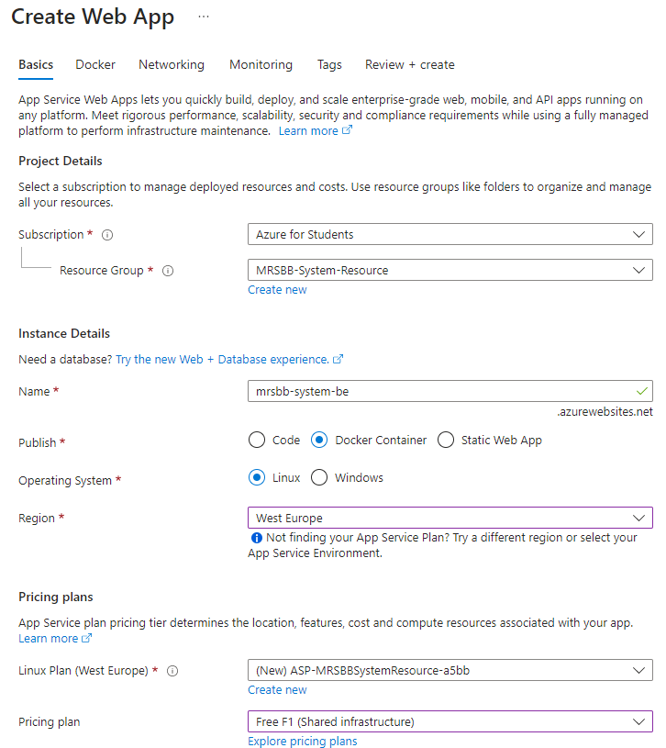

After that we need to identify the docker image and tag

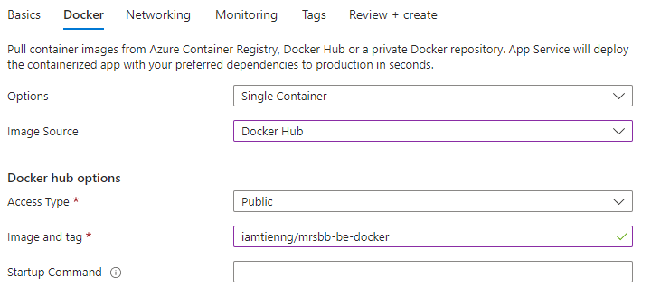

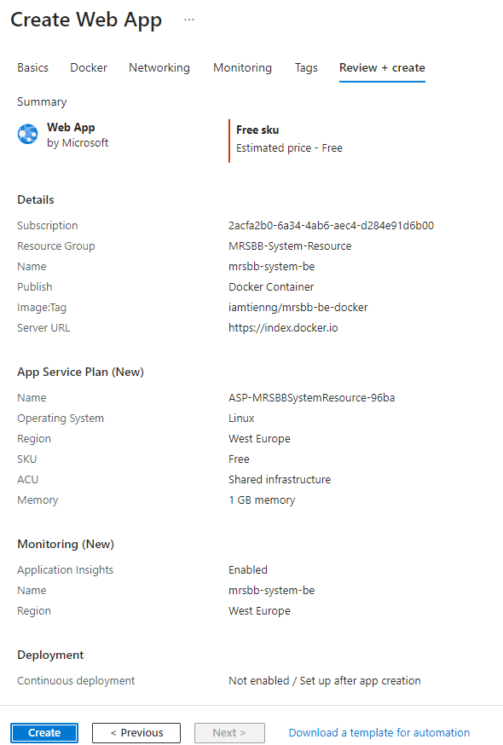

After creating the webapp, we need to wait for azure to deploy.

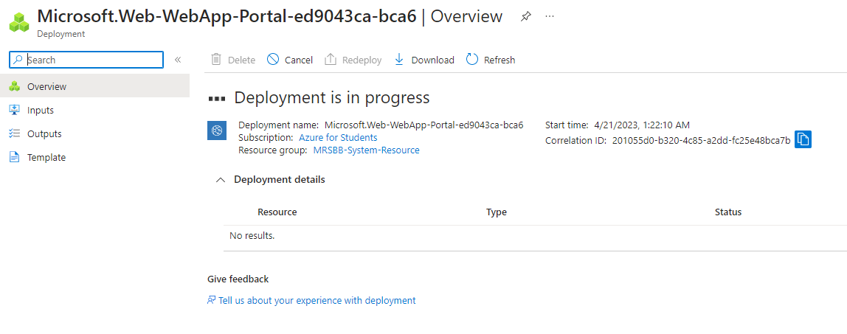

After that, our Backend is completely deployed

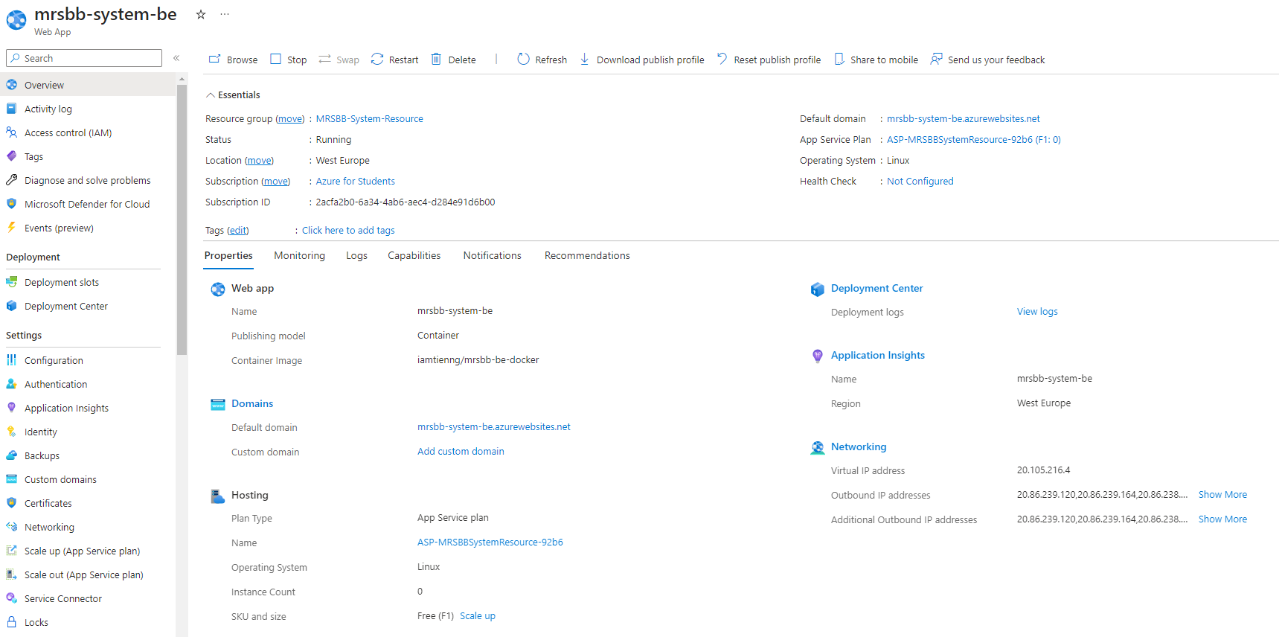

## Frontend Deployment

Again, we create another Web App on Azure portal for Frontend: 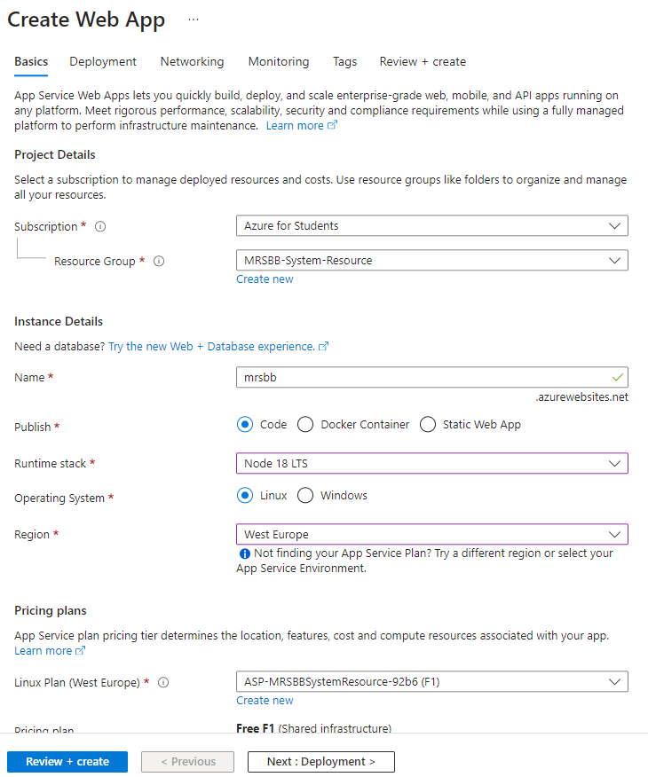

But this time, we will not configure on Azure portal, we will use Azure DevOps Pipeline instead.

Before we handle Pipeline, we need to change Backend API URL in Frontend by modifying the .env file:



After that, we need to use Git to push our source code to Repos in MRSBB System Project on Azure DevOps:

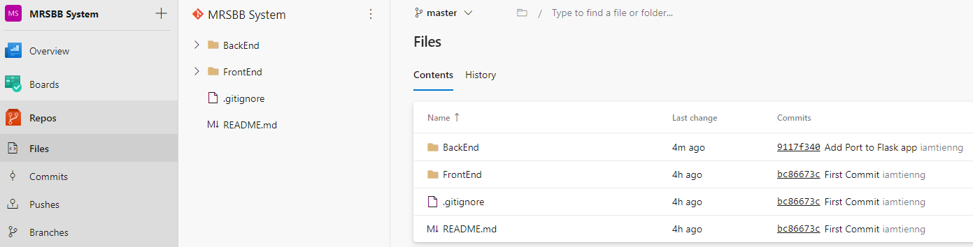

Select “Use the classic editor”.

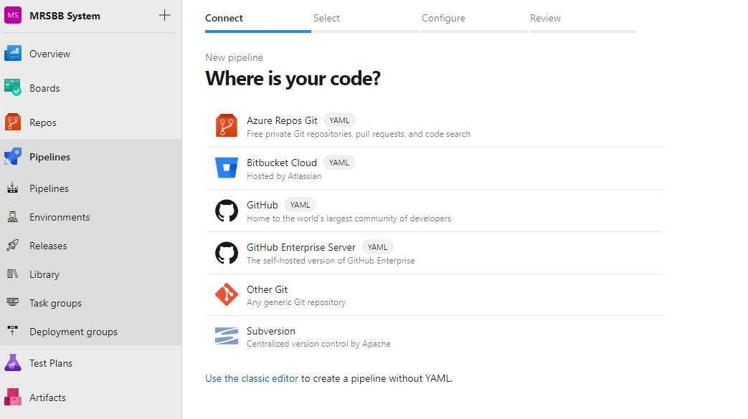

Select Azure Repos Git as repository for Pipeline

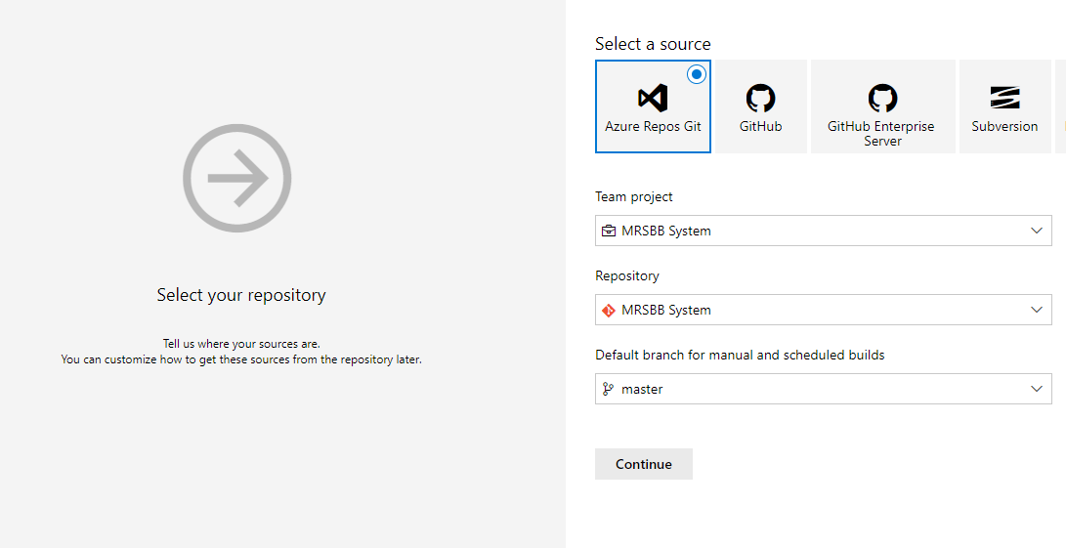

Choose to start with an Empty job. We will set up 3 jobs, careful the path for npm run build and Publish Artifact: drop

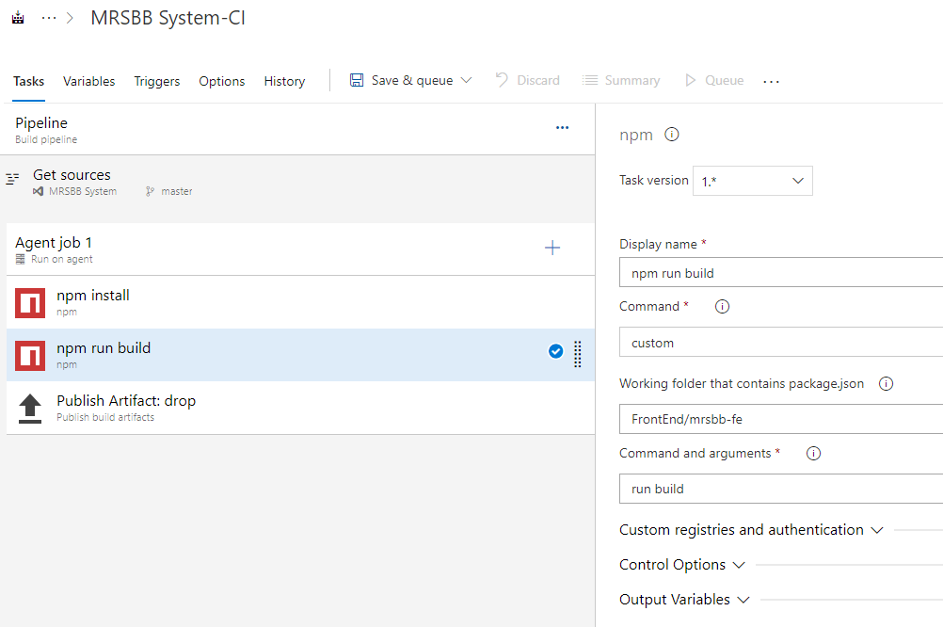

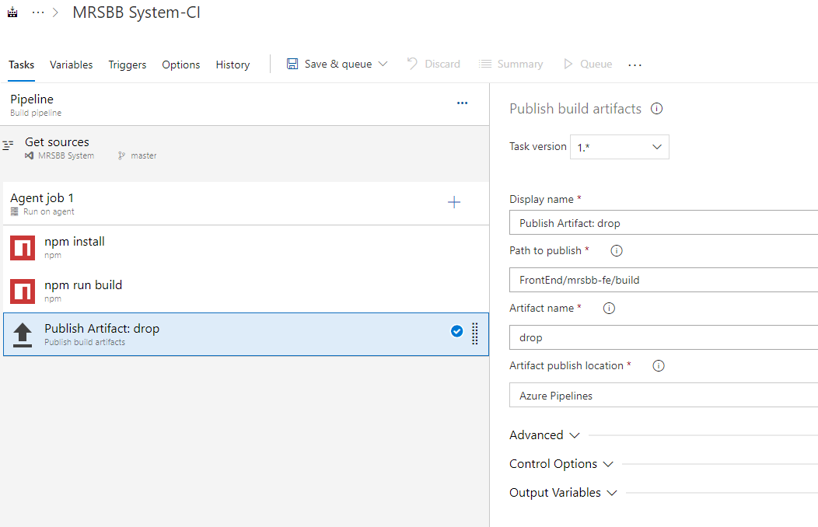

Go to the Triggers tab and select Enable continuous integration.

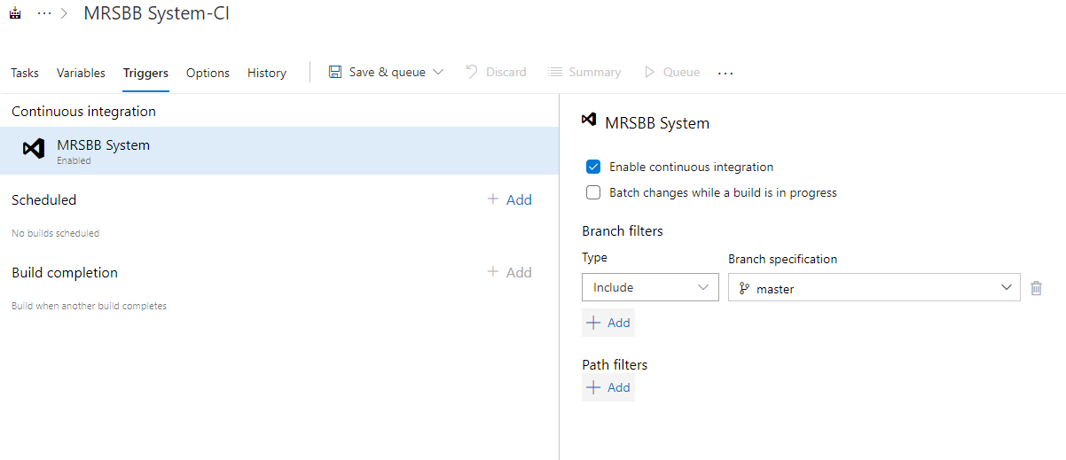

Click on Save & queue dropdown in the top menu and then click on Save & queue option. Run pipeline modal will open. Change Agent Specification to ubuntu latest and click on Save and run button.

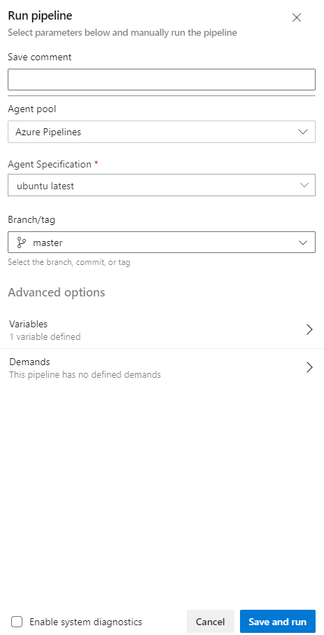

After queue and run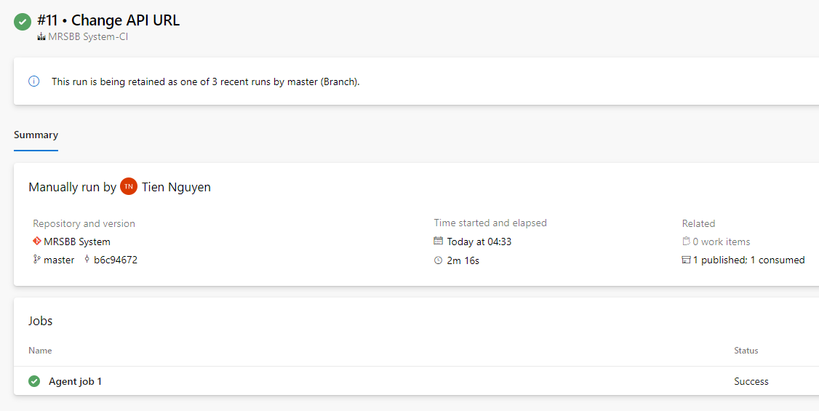

Steps to create a Release Pipeline

1. Create a new pipeline by selecting Pipelines -> Releases and clicking on New pipeline button.

2. Select template Azure App Service deployment and click on Apply button.

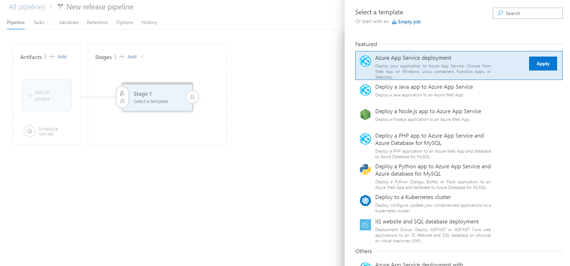

3. Set Stage name to Release.

4. Click on Add an artifact and select the build pipeline that we created previously as Source. Click on Add button.

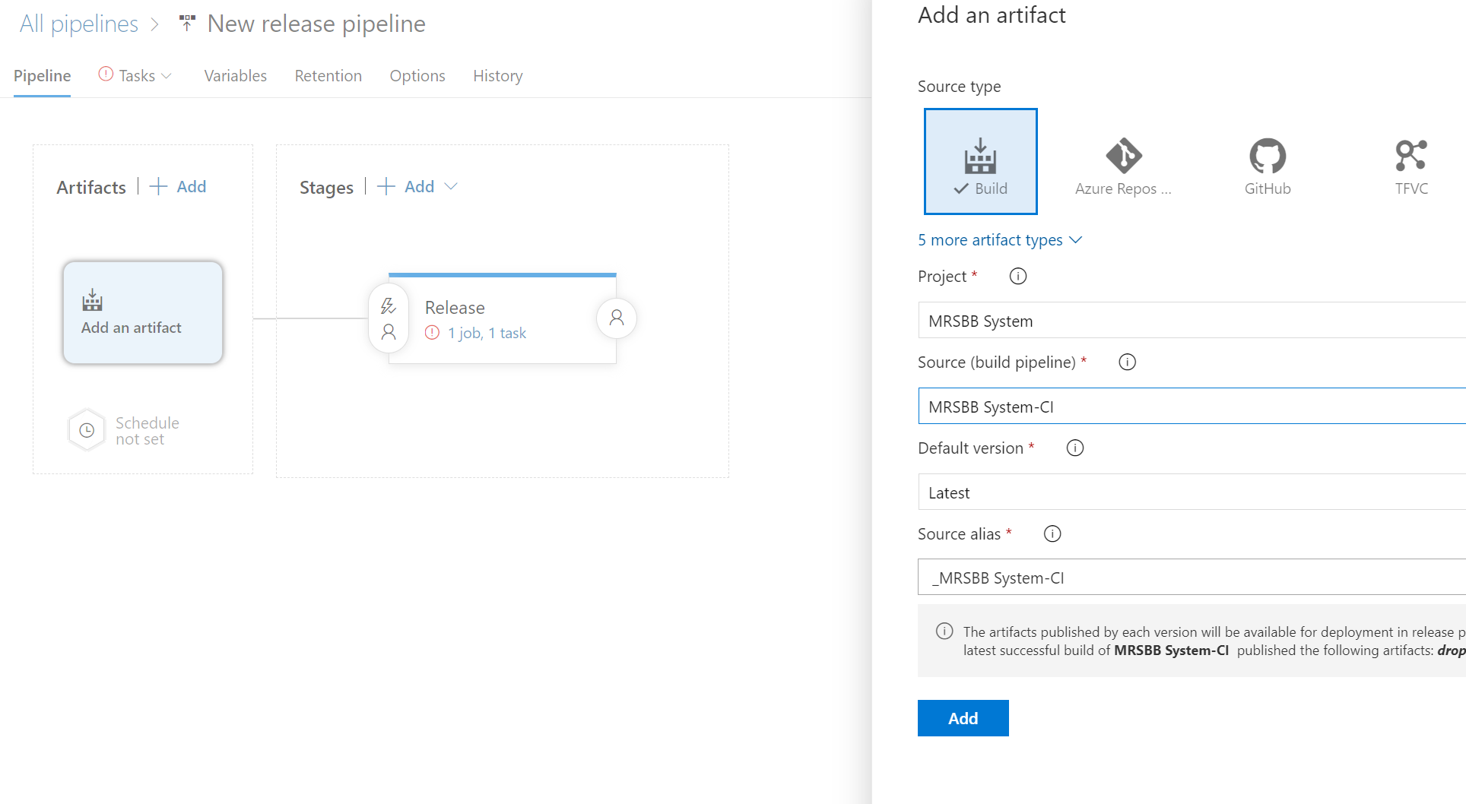

Steps to configure Continuous Deployment

1. Click on the lightning icon in Artifacts and enable Continuous deployment trigger. This will create a new release every time a new build is available. Also add main branch as build branch filter and close the dialog.

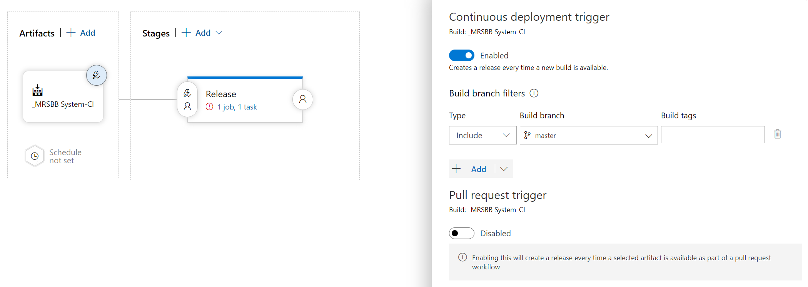

2. Click on 1 job, 1 task link in Stages block to finish configuration of the Azure App Service deployment. Select our Azure subscription. We will be asked to authorize it by clicking on Authorize button. Also select App service name which we created previously.

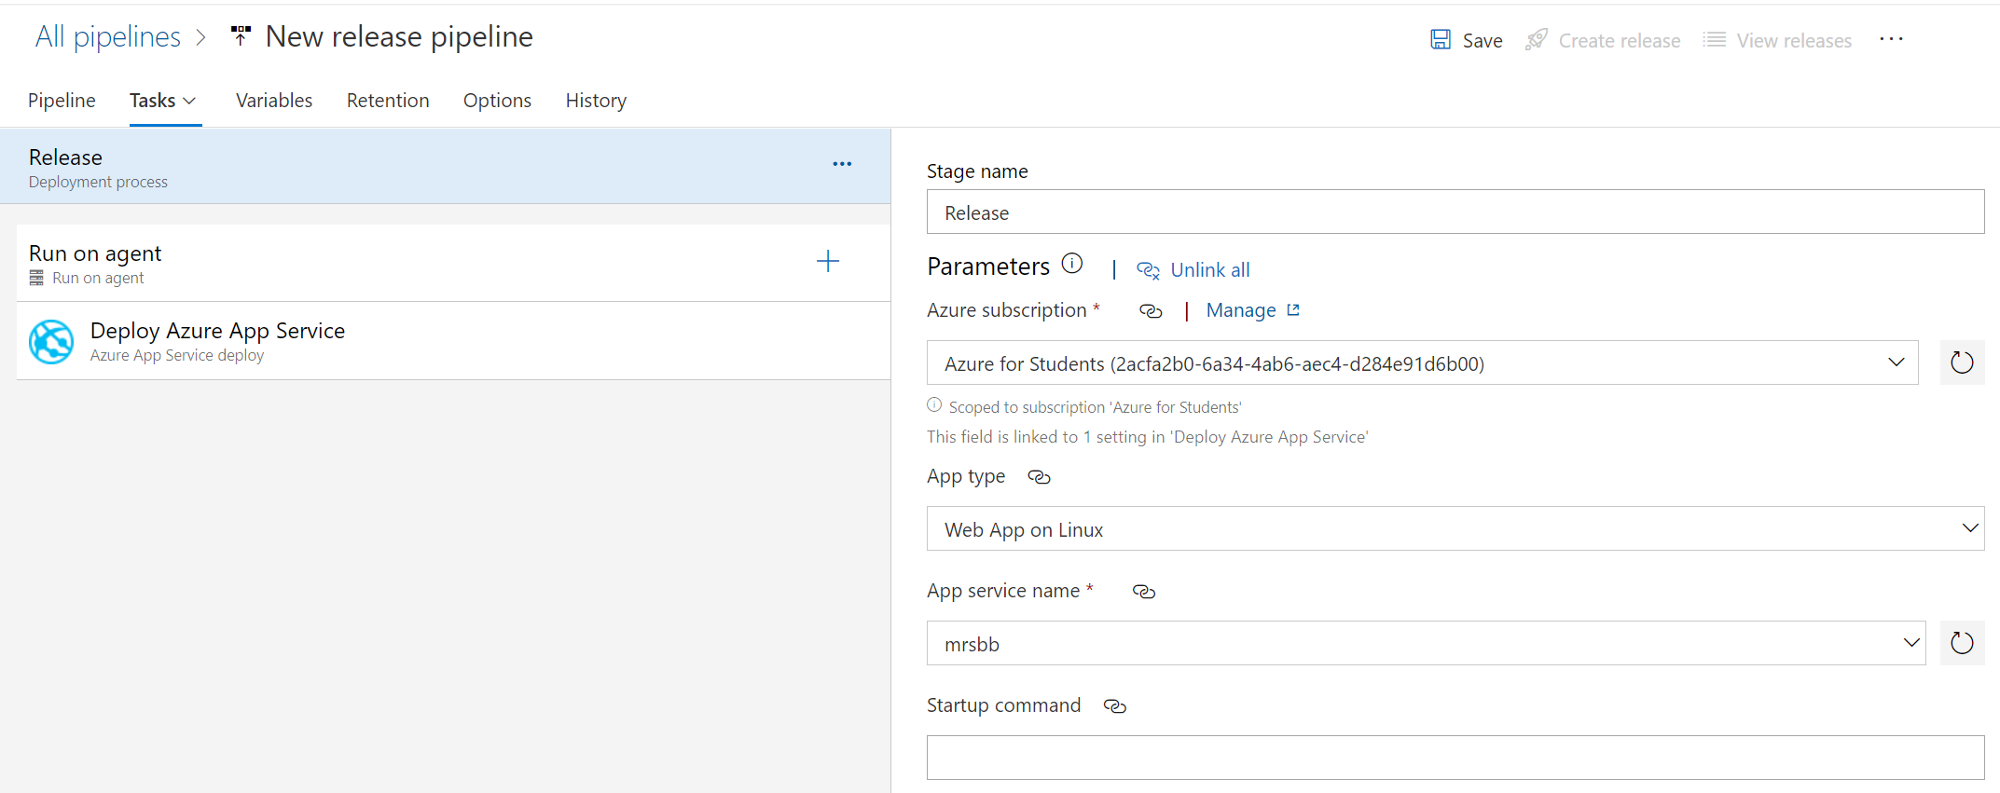

3. Click on Deploy Azure App Service and select drop folder as folder which contains app service contents generated in build process.

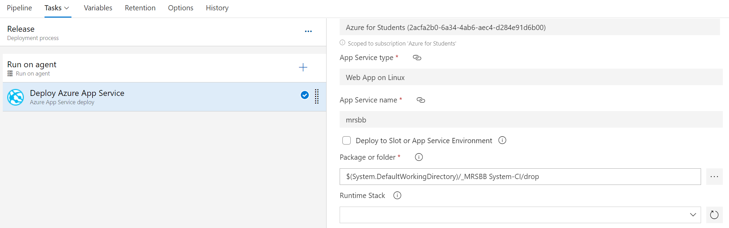

4. Click on Save in the top right corner and then click on OK without changing anything in the modal dialog which will appear.

5. Now click on Create release (next to the Save button) which will become enabled. Another modal dialog will appear, but we can leave everything as it is and click on the Create button.

6. Under Pipelines -> Releases we can see the newly created release pipeline running. It may take a few minutes until it succeeds.

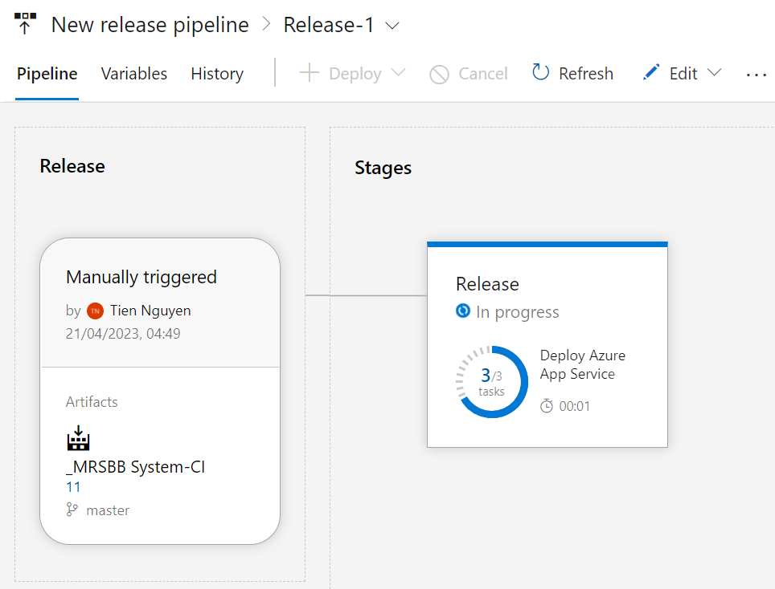

Once release pipeline is successfully completed, we should be able to see your deployed application on <https://mrsbb.azurewebsites.net>

Finally, we need to setup Startup Command in Configuration of mrsbb on Azure Portal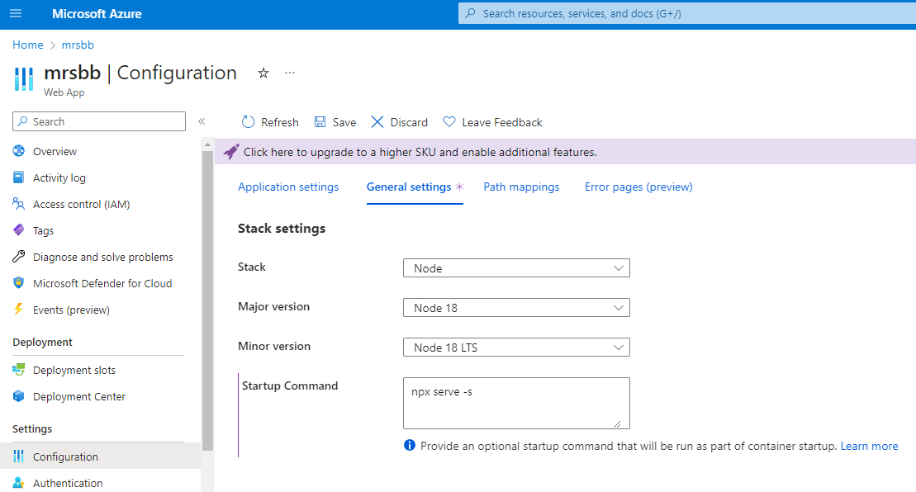

From now on whenever we push new source code to the main branch, a new deployment for Frontend will be automatically run.

## Scale solutions

A machine learning-based system in general and a recommendation system in particular will both be better as soon as the system becomes viral and has a large amount of data from a large number of users. At this point, we have to deal with the scale of the system.

There are two solutions to this problem that correspond to the two traditional scaling methods:

* Scale-up: Keeping only one object of the recommendation system when the Backend is initialized is great for Scale Up. But we are deploying the system as a micro-service (using docker to package the container and run it on a virtual machine of the azure server) and won't be able to take advantage of creating multiple replicas to serve more users. Updating the model in the database is extremely resource-intensive because the model needs to be updated with both a matrix as well as an array each time it needs to be updated.
* Scale-out: To be able to Scale Out the system. We can redesign the database so that each element in model W, X, d, b is a separate table. Every time there is a new user, W will be added a row and d will be added a number. Similarly, X and b will be added new values when Admin adds a new movie. Every time a user uses Rating Management, we only need to update a row of W and a value in list d to be able to use that value for another replica of the Backend. When the user needs to get the predicted rating for a movie, we only need to load a line of W and X and a value of d and b to get the result, not the whole model as before.

# Recommendation System Algorithm Design

The model for Recommendation System in this project is the 3rd model in the research: Matrix Factorization. For full details about the model, please refer to the file “Recommendation_System”. I will write a quick explanation follow.

## Foundation

A key idea in recommendation systems, particularly in collaborative filtering, is the utility matrix. It is a matrix that records how a recommendation system’s users interact with the items or simply rate them. The cells of the matrix contain the ratings or interactions between the users and the items, while the rows and columns of the matrix represent the users and the items, respectively.

|  |  |  |  |  |  |  |  |
| --- | --- | --- | --- | --- | --- | --- | --- |
|  | A | B | C | D | E | F | Figure 3.6: An example of utility matrix with song recommendation system. Songs (items) are rated by users on a scale from 0 to 5 stars. The “?” marks indicate that the data does not yet exist in the database. The recommendation system needs to manually fill in these values. |
| Bohemian Rhapsody | 5 | 5 | 0 | 0 | 1 | ? |
| I Love Rock 'N Roll | 5 | ? | ? | 0 | ? | ? |
| Hotel California | ? | 4 | 1 | ? | ? | 1 |
| Twinkle, Twinkle Little Star | 1 | 1 | 4 | 4 | 4 | ? |
| Happy and You Know It | 1 | 0 | 5 | ? | ? | ? |

In content-based recommendation systems, each item is described by a vector x called the item profile. In that method, we need to find a coefficient vector w corresponding to each user such that the known rating that user gives the item is approximately equal to:

$$y≈w^{T}x=x^{T}w$$

With this approach, the utility matrix Y, assuming it is filled, will approximate to:

$Y≈\left[\begin{matrix}x_{1}^{T}w_{1} & x_{1}^{T}w_{2} & … & x_{1}^{T}w_{N} \\ x_{2}^{T}w_{1} & x_{2}^{T}w_{2} & … & x_{2}^{T}w_{N} \\ … & … & … & … \\ x_{M}^{T}w_{1} & x_{M}^{T}w_{2} & … & x_{M}^{T}w_{N}\end{matrix}\right]$ = $\left[\begin{matrix}x_{1}^{T} \\ x_{2}^{T} \\ … \\ x_{M}^{T}\end{matrix}\right]\left[w_{1} w_{2}… w_{N}\right]$ = $X^{T}W$

$M$: number of items.

$N$: number of users.

Now, suppose that we do not need to pre-construct the $x$ profile items, but that the feature vector for each of these items can be trained concurrently with each user's model (here, a coefficient vector). This means, the variables in the optimization problem are both $X$ and $W$; where, $X$ is the matrix of the entire profile item, each column corresponds to an item, $W$ is the matrix of the entire user model, each column corresponds to a user.

With this approach, we are trying to approximate the utility matrix $Y∈R^{MxN}$ by the product of two matrices $X∈R^{MxK}$ and $W∈R^{KxN}$. Usually, $K$ is chosen to be a much smaller number than $M$, $N$. Then, both the $X$ and $W$ matrices have a rank not exceeding $K$. Therefore, this method is also called low-rank matrix factorization.

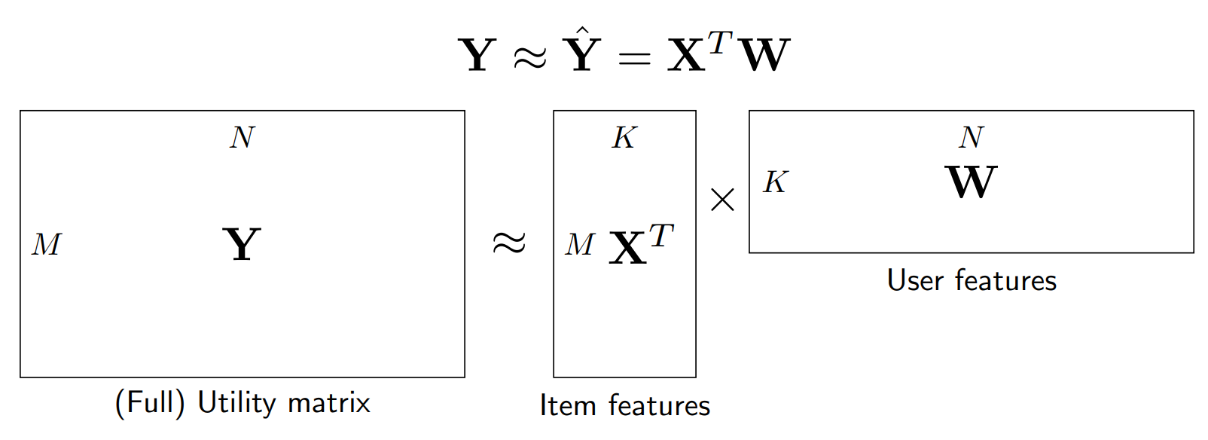

## Loss Function

The loss function for the Matrix Factorization Collaborative Filtering can be written as:

$$L\left(X,W,b,d\right)=\frac{1}{2s}\sum_{n=1}^{N}{ }\sum_{m:r_{mn}=1}{ }\left(x_{m}^{T}w_{n}+b_{m}+d_{n}-y_{mn}\right)+\frac{λ}{2}({\left\|X\right\|}_{F}^{2}+{\left\|W\right\|}_{F}^{2})$$

$r_{mn}=1$ if m-th item has been rated by n-th user.

s: number of ratings in dataset.

$y_{mn}$: rating of $n-th$ user for $m-th$ item.

${\left\|X\right\|}_{F}$: Frobenius norm of X.

$\frac{1}{2s}\sum_{n=1}^{N}{ }\sum_{m:r_{mn}=1}{ }\left(x_{m}^{T}w_{n}+b_{m}+d_{n}-y_{mn}\right)$ is the loss data, is the mean error of the model.

$\frac{λ}{2}({\left\|X\right\|}_{F}^{2}+{\left\|W\right\|}_{F}^{2})$ is $l_{2}$ regularization loss, help avoid overfitting.

Simultaneous optimization of $X, W, b, d$ is relatively complicated. Instead, the method used is to optimize one of the two pairs $(X, b), (W, d)$ in turn, while the other pair is fixed. This process is repeated until the loss function converges.

## Optimizing the loss function

When the pair $(X, b)$ is fixed, the pair $(W, d)$ optimization problem can be decomposed into $N$ subproblems:

$$L_{1}\left(w_{n},d_{n}\right)=\frac{1}{2s}\sum_{m:r_{mn}=1}{ }{\left(x_{m}^{T}w_{n}+b_{m}+d_{n}-y_{mn}\right)}^{2}+\frac{λ}{2}({\left\|w_{n}\right\|}_{2}^{2})$$

Each problem can be optimized using gradient descent. Our important job is to calculate the derivatives of each of these small loss functions with respect to $w_{n},d_{n}$. Since the expression in the sign Sigma depends only on the items that have been rated by the user in question (corresponding to $r_{mn}=1$), we can simply by making ${\hat{X}}_{n}$ a submatrix generated by the columns of X corresponds to the items that have been rated by user n, ${\hat{b}}_{n}$ is the corresponding sub-bias vector, and ${\hat{y}}_{n}$ is the corresponding rating. Then:

$$L_{1}\left(w_{n},d_{n}\right)=\frac{1}{2s}{\left\|{\hat{X}}_{n}^{T}w_{n}+{\hat{b}}_{n}+d_{n}1-{\hat{y}}_{n}\right\|}^{2}+\frac{λ}{2}({\left\|w_{n}\right\|}_{2}^{2})$$

With 1 is the vector with all elements equal to 1 and the appropriate size. Its derivative is

$$∇_{w_{n}}L_{1}=\frac{1}{s}{\hat{X}}_{n}\left({\hat{X}}_{n}^{T}w_{n}+{\hat{b}}_{n}+d_{n}1-{\hat{y}}_{n}\right)+λw_{n}$$

$$∇_{b_{n}}L_{1}=\frac{1}{s}1^{T}\left({\hat{X}}_{n}^{T}w_{n}+{\hat{b}}_{n}+d_{n}1-{\hat{y}}_{n}\right)$$

**Update equation for $w_{n},d_{n}$:**

$$w_{n}←w_{n}-η\left(\frac{1}{s}{\hat{X}}_{n}\left({\hat{X}}_{n}^{T}w_{n}+{\hat{b}}_{n}+d_{n}1-{\hat{y}}_{n}\right)+λw_{n}\right)$$

$$d_{n}←d_{n}-η\left(\frac{1}{s}1^{T}\left({\hat{X}}_{n}^{T}w_{n}+{\hat{b}}_{n}+d_{n}1-{\hat{y}}_{n}\right)\right)$$

$η$ is the learning rate.

Similarly, each column $x_{m}$ of $X$, which is the feature vector for each item, and $b_{m}$ can be found by optimizing the problem:

$$L_{2}\left(x_{m},b_{m}\right)=\frac{1}{2s}\sum_{n:r_{mn}=1}{ }{\left(w_{n}^{T}x_{m}+d_{n}+b_{m}-y_{mn}\right)}^{2}+\frac{λ}{2}({\left\|x_{m}\right\|}_{2}^{2})$$

Let ${\hat{W}}_{m}$ be the matrix created with the columns of $W$ corresponding to the users who have rated item m, ${\hat{d}}_{m}$ the corresponding bias sub-vector, and ${\hat{y}}_{m}$ the corresponding rating vector. The problem becomes:

$$L_{2}\left(x_{m},b_{m}\right)=\frac{1}{2s}{\left\|{\hat{W}}_{m}^{T}x_{m}+{\hat{d}}_{m}+b_{m}1-{\hat{y}}_{m}\right\|}^{2}+\frac{λ}{2}({\left\|x_{m}\right\|}_{2}^{2})$$

**Update equation for $x_{m},b_{m}$:**

$$x_{m}←x_{m}-η\left(\frac{1}{s}{\hat{W}}_{m}\left({\hat{W}}_{m}^{T}x_{m}+{\hat{d}}_{m}+b_{m}1-{\hat{y}}_{m}\right)+λw_{m}\right)$$

$$b_{m}←d_{m}-η\left(\frac{1}{s}1^{T}\left({\hat{W}}_{m}^{T}x_{m}+{\hat{d}}_{m}+b_{m}1-{\hat{y}}_{m}\right)\right)$$

## Development in Python

First, we will write a Matrix Factorization class that performs the optimization of variables with a utility matrix given in the form of Y_data just like with NBCF. First, we declare some necessary libraries and initialize the Matrix Factorization class:



Next, we write loss, updateXb, updateWd methods for class MF:







The next part is the main optimization process of MF (fit), predicting the new rating (pred) and evaluating the model quality by root-mean-square error (evaluate_RMSE).



At this point, we have built into the Matrix Factorization class with the necessary methods.

## Model input explanation

Input for Matrix Factorization will be:

Utility matrix Y is a numpy.ndarray which includes all existed ratings, there are 4 columns in Y, userId, movieId, rating, timestamp. 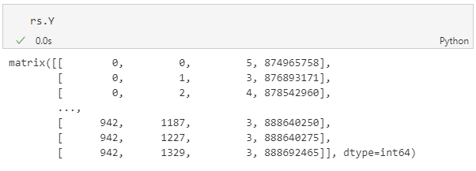

K: number of features, this value is used to approximate the utility matrix $Y∈R^{MxN}$ by the product of two matrices $X∈R^{MxK}$ and $W∈R^{KxN}$.

lam: lambda $λ$

learning_rate: learning rate of model

Example of learning rate too small:

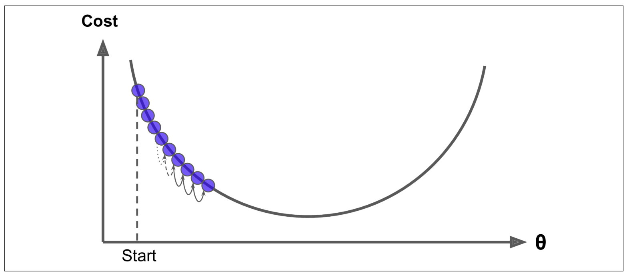

Example of learning rate is too large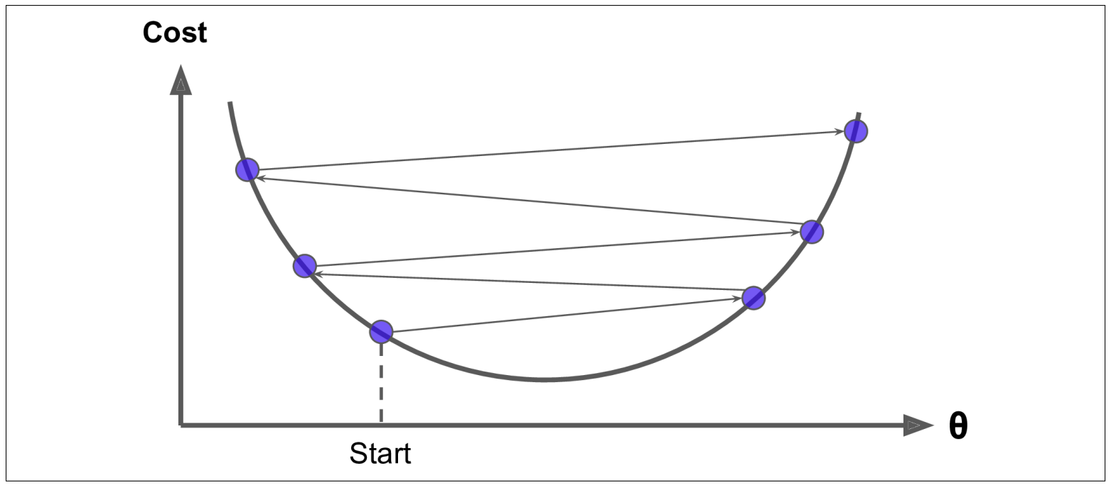

max_iter: maximum iteration of gradient descent used to find $X$ and $W$, it appears in fit().

print_every: this value is for system to report processing during the training session.

n_users: number of existed users

users_ids: a list of all user ids

n_items: number of existed movies

items_ids: a list of all movie ids

n_ratings: number of existed ratings

X: a matrix has size $n_items × K$

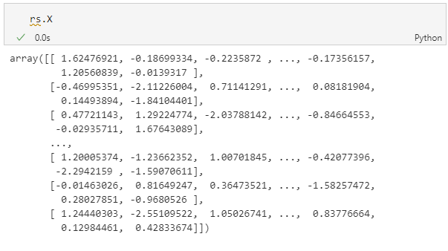

W: a matrix has size $K×n_users$

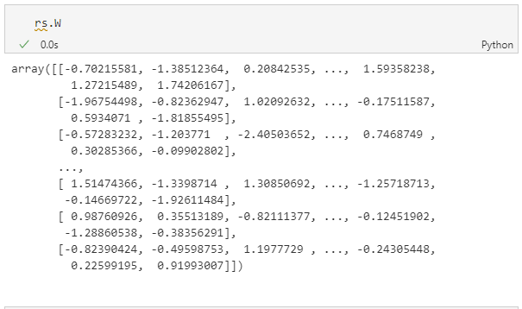

b: item biases, an array with length of n_items.

d: user biases, an array with length of n_users.

## Model explanation

With the input $Y$, we try to determine $X, W, b and d$ such that the formula $y_{mn}≈x_{m}^{T}w_{n}+b_{m}+d_{n}$ will come close to value in $Y$.

Loss function is a way we calculate the difference between the value in Y and value calculated by $X, W, b and d$.

The way we find the right $X, W, b and d$ is gradient descent with the update formula shown before.

When $X, W, b and d$ are optimized, we can use them to calculate the prediction for unknown value in utility matrix Y.

## Functions that affect the model

FR.1.1: User Registration

When a new user signs up, the model needs to update with n_users, users_ids, W and d.

FR.3.1: User Create Rating, FR.3.3: User Update Rating, FR.3.4: User Delete Rating

When a new user handles a rating, the model should update W and d for that user.

FR.7.3: Admin Add New Movie

When an Admin adds a new movie, same as FR.1.1, we need to update the model.

## Model application

When Backend component started, there will be an object of matrix factorization in extensions.py.

There are 5 initial inputs: Y, X, W, b, d.

For X, W, b and d, we load it with saved trained model in database, if there is nothing in database, we will load it in the csv file I prepared in Data Preparation section.



For Y, we need to load all ratings in database

Finally, we can create a model object that live when server running:



Whenever a function that affects model is called, it will call directly to the only one live object.

For example, please refer to the register method in People class.

# Production Screenshots

